

HAND OUT DATE: 18 2023

HAND IN DATE: 20 2024

WEIGHTAGE:

INSTRUCTIONS TO CANDIDATES:

**1 Students are advised to underpin their answers with the use of references (cited using the American Psychological Association (APA) Referencing).**

**2 Late submission will be awarded zero (0) unless Extenuating Circumstances (EC) are upheld.**

**3 Cases of plagiarism will be penalized.**

**4 Submit the assignment to APU Learning Management System.**

**5 You must obtain 50% overall to pass this module.**

**Group No: 103**

**Member 1: Ho Rong Wei TP065092**

**Member 2: Chew Jin Ni TP064851**

**Member 3: Damon Ng Khai Weng TP064820**

**Member 4: Aryssa Goh May Lynn TP072774**

**Table of Contents**

1.0 Introduction 5

1.1 Data Description 5

1.2 Assumptions 5

1.3 Hypothesis and Objectives 5

2.0 Data Preparation 6

2.1 Data import 6

2.2 Cleaning/Pre-processing 7

**2.2.1 Clean Location** 7

**2.2.2 Clean Property type** 7

**2.2.3 Clean Price** 8

**2.2.5 Clean Property Size** 8

**2.2.6 Cleaning Rooms** 12

3.0 Data Analysis 14

3.1 Objective 1: To investigate the relationship between number of car park and property price. 14

**Analysis 3.1.1 How does the average property price vary with the number of car parks available?** 14

**Analysis 3.1.2 Can the number of car parks predict property prices, and if so, what is the regression equation that best describes this relationship?** 16

**Analysis 3.1.3 What is the relationship between property prices and the number of car parks provided, considering different property types?** 18

**3.1.4 Conclusion** 21

3.2 Objective 2: To investigate the relationship between property price and location. 22

**Analysis 3.2.1: Which location possesses the highest price and the lowest average property price?** 22

**Analysis 3.2.2: What is the cluster patterns of property price range based on location?** 23

**Analysis 3.2.3: Do adjacent locations have similar property price range?** 24

**Analysis 3.2.4: Does the distance of each location from the heart of Kuala Lumpur (KLCC) affect the property price?** 25

**3.2.5: Conclusion** 25

**3.2.6 Extra Features** 26

3.3 Objective 3: To investigate the relationship between number of rooms and property price. 28

**Analysis 3.3.1 How does the number of rooms of a property in KL influence the price of a property?** 28

**Analysis 3.3.2 Are there any special cases (outliers) where specific number of rooms have a lot more expensive price than the average?** 32

**Analysis 3.3.3 Does the presence of extra rooms have any significant effect on the properties price?** 34

**3.3.4 Conclusion:** 36

3.4 Objective 4: To investigate the relationship between property size and property price. 37

**Analysis 3.4.1: How is the property price and property size correlated?** 37

**Analysis 3.4.2: What range of the property size contributes to higher cost in property price?** 40

**Analysis 3.4.3: Does the common average size of the condominiums in Kuala Lumpur have similar prices?** 42

**3.4.4 Findings summary** 44

4.0 Conclusion 45

4.1 Overall Discussion 45

4.2 Recommendation 45

4.3 Limitation and Future Direction 45

5.0 Appendix 46

Workload Matrix 46

6.0 References 47

# 1.0 Introduction

## Data Description

The dataset consists of 53883 rows and 8 columns. Each row represents a house property, and each column represents the information of the property. In this case, there are “Location”, “Price”, “Rooms”, “Bathrooms”, “Car Parks”, “Property Type”, “Size”, and “Furnishing” column which each represents the location, price, number of rooms, number of bathrooms, number of car parks, property type, size, and furnishing status of the property.

## Assumptions

1. The property size unit is in sq ft.
2. Largest property is 37000 sq ft.
3. Property greater than RM2000000 is considered expensive properties.
4. Assume Taman Yarl Oug is same as Taman Yarl.
5. Assume Jalan U-thant is same as U-thant.
6. Assume Sri Kembangan is same as Seri Kembangan.
7. Assume KL city, City Central, Kuala Lumpur and City Center is same as KLCC.
8. Assume Sri Damansara is same as Bandar Sri Damansara.
9. Assume Desa Parkcity is same as Adiva Desa Parkcity.
10. The lowest price to buy a house is RM580,000.

## Hypothesis and Objectives

**Hypothesis:**

The price of properties in Kuala Lumpur is influenced by number of car parks, number of rooms, size, and location.

**Objectives:**

1. To investigate the relationship between number of car park and property price.
2. To investigate the relationship between property price and location.
3. To investigate the relationship between property size and property price.
4. To investigate the relationship between number of rooms and property price.

# 2.0 Data Preparation

## 2.1 Data import

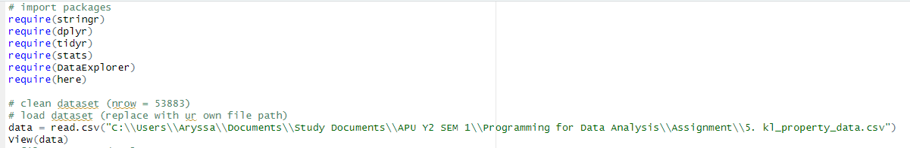

Figure 1: R Script for import necessary packages and dataset.

Output:

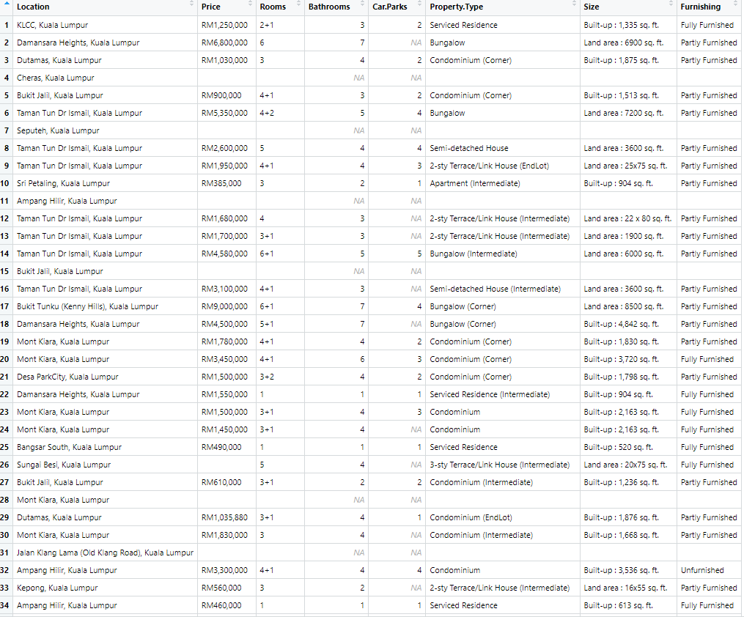

Figure 2: Dataset imported.

Before the start of exploring and analysing data, the libraries and datasets are imported. The ‘require()’ function is used to check whether the packages specified is installed and load the packages into the current R session. In this case, there are six libraries being loaded and used for further data cleaning. The dataset “kl_property_data.csv” is a csv loaded in as a data frame “data” using the read.csv() function, setting the header to true, where the first row of the csv file being used as the column names in the data frame.

## 2.2 Cleaning/Pre-processing

### **2.2.1 Clean Location**

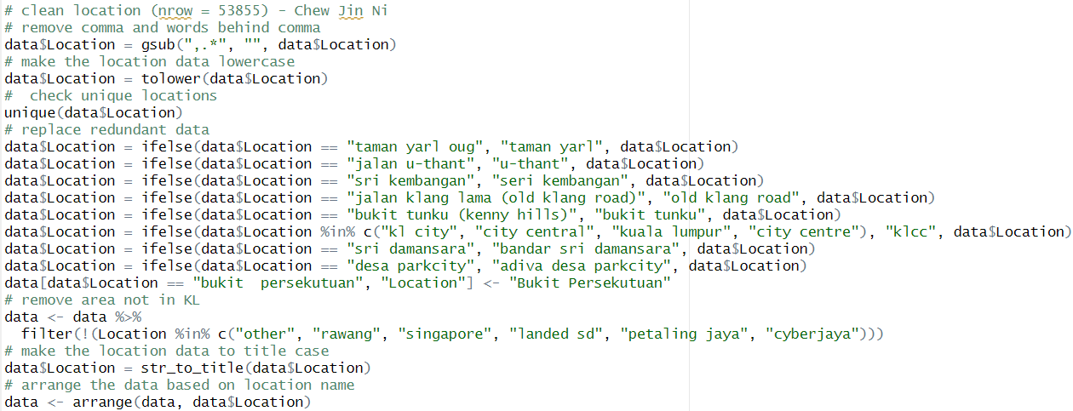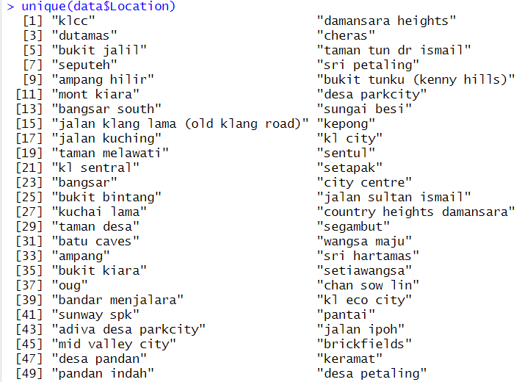

Figure 3: R Script for clean location data. Figure 4: Unique locations.

The location data is cleaned by removing the comma and words behind comma. The locations are converted to lowercase to avoid case sensitive in further cleaning process. Unique locations are retrieved to check similar location names. The duplicated locations are combined into single location. The extra spaces between words, irrelevant locations, and locations out of Kuala Lumpur are cleaned. The locations are converted to title case and arrange ascendingly to make the data neater.

### **2.2.2 Clean Property type**

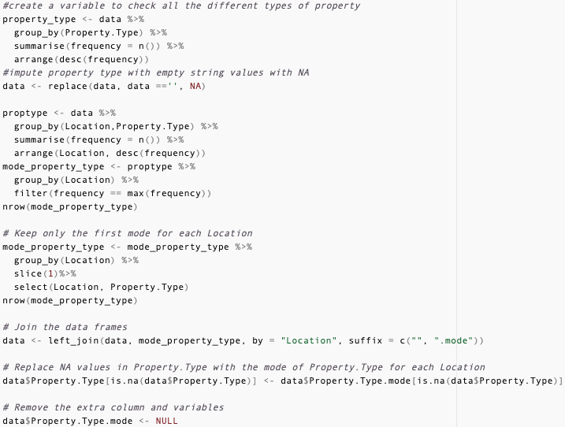

Figure 5: R script to clean property type data.

The “Property.Type” column is cleaned by first having the empty string values in the original data frame imputed with NA for easy detection during imputation. After that, a data frame storing all the different types of property for each location is created to get the most common property type by each location. If there turns out to be multiple mode property types for a location, only the first is kept. Lastly, the mode property type data are left-joined to the original data frame and used to impute the missing property type values via their location.

### **2.2.3 Clean Price**

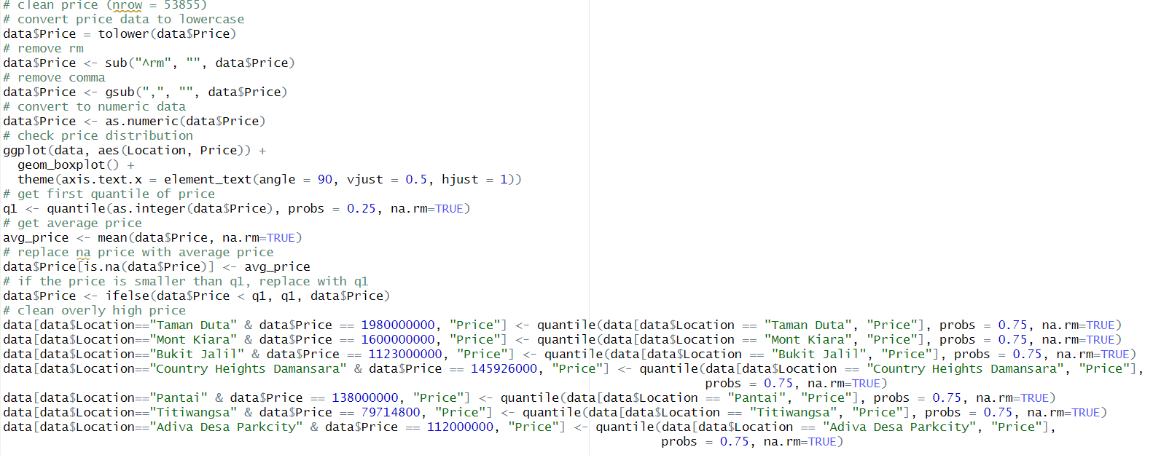

Figure 6: R Script for clean price data.

The price data is converted to lowercase, then “rm” and “,” are eliminated. The price data is then converted to numeric data for further calculation. Boxplot is generated to help in determining price outliers in each location. The price smaller than q1 is replaced by q1. The average property price is computed to replace NA price data. The overly high price is observed from boxplot in Figure 2 below and manually cleaned using q3.

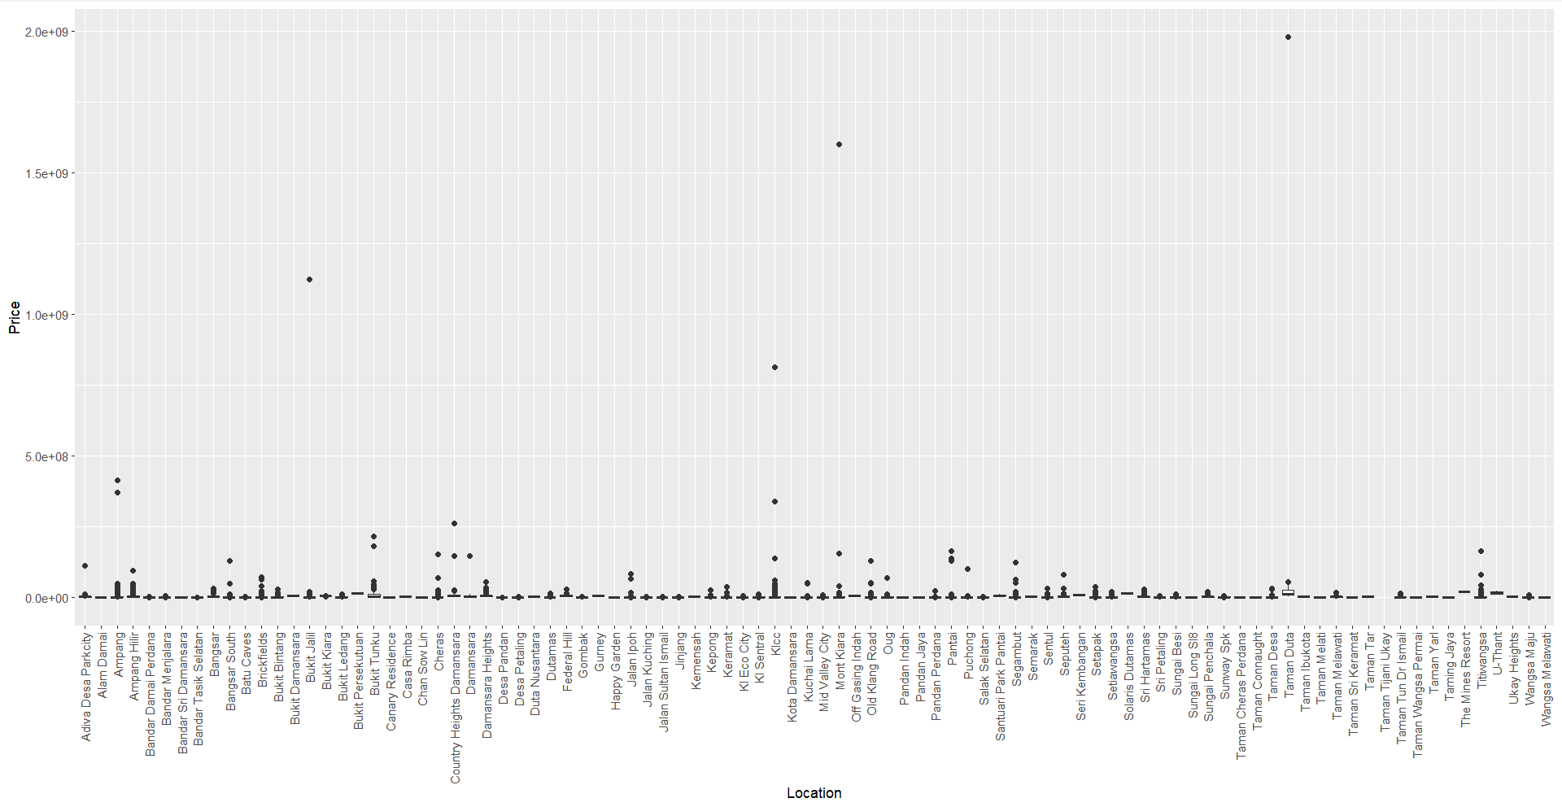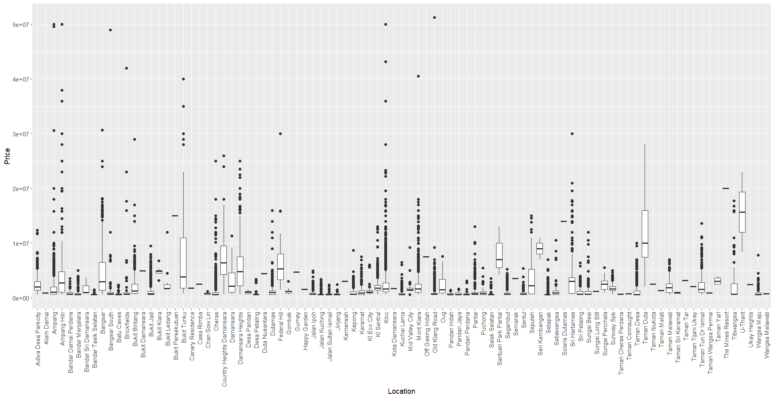

Figure 7: Boxplot for uncleaned price data. Figure 8: Boxplot for cleaned price data.

The above boxplots show the price distribution before and after price data cleaning. The cleaned price data looks more reasonable than the uncleaned price data.

### **2.2.5 Clean Property Size**



Figure 9: R-Script to split size column into 2.

The “Size” column of the dataset is first split into 2 columns “Land Type” and “Land.Size.Sq.ft”.

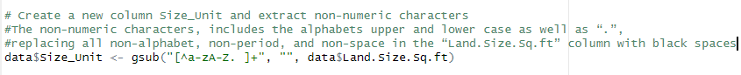

Figure 10: R-Script to create new column for Size Unit

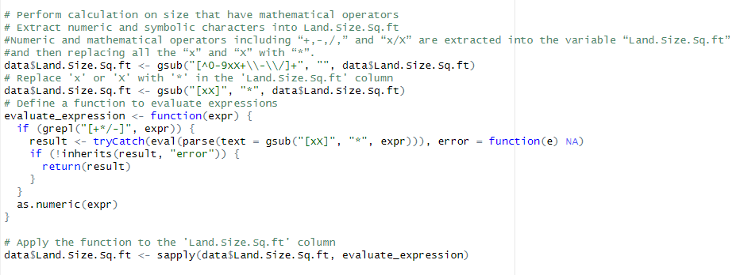

Figure 11: R-Script to perform mathematical calculation on size with operators.

Calculation is then performed on sizes that have mathematical operators using a function defined as “evaluate_expression” which uses eval() function to evaluate the expressions.

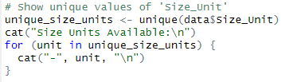

Figure 12: Check unique values in Size Unit column.

Unique values of “Size_Unit” is shown below.

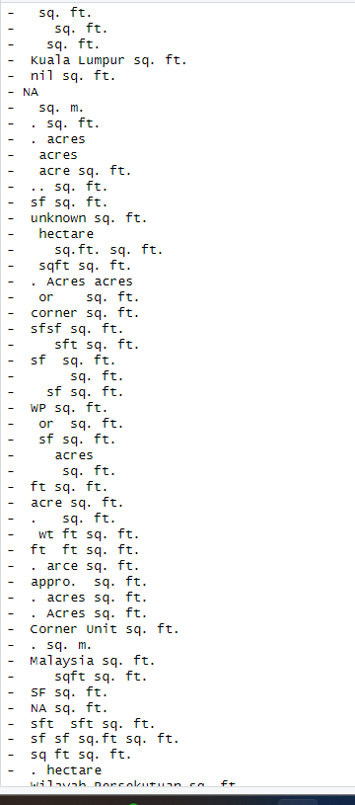

Figure 13: Unique values in Size Unit

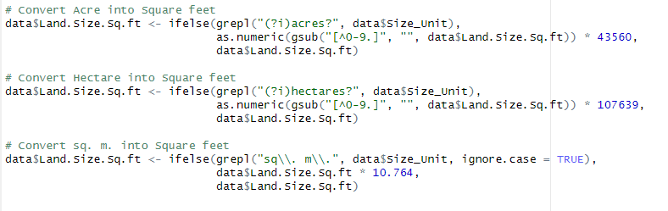

Figure 14: R-Script for Conversion

Conversion from Acre, Hectare, and sq.m. into square feet is done.

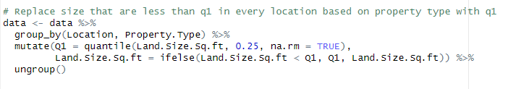

Figure 15: R-Script to replace size that are less than q1.

Illogical data such as size lesser than quartile 1 in every location based on property type is replaced with quartile 1 of every location based on property type.

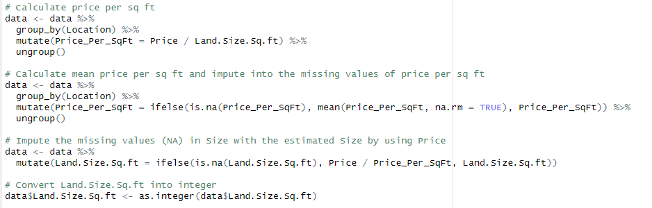

Figure 16: R-Script to impute size for NA data.

Missing values in Size imputed with estimated size by dividing Price with Price_per_sq_ft. The mean price per sq ft is used to impute into missing values of price per sq ft.

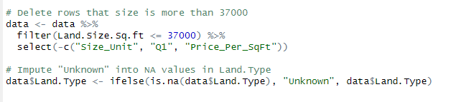

Figure 17: R-Script to delete rows for illogical size and impute 'Unknown' in Land Type

As for sizes more than 37000 sq ft is deleted. This is because the largest property size in Malaysia is found to be 36069.8638 sq ft (PropertyGuru, 2022). “Unknown” is imputed into NA values in “Land.Type” column.

### **2.2.6 Cleaning Rooms**

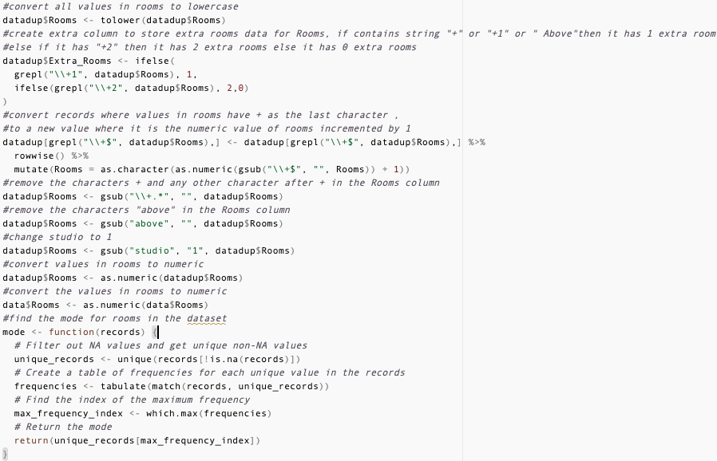

Figure 18: Setup extra rooms column.

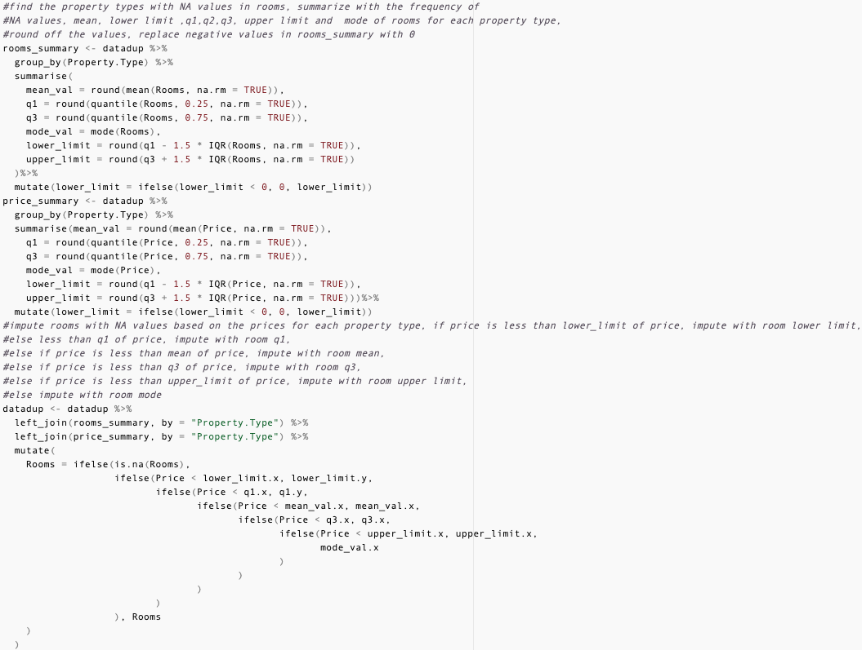

Figure 19: Conditionally impute missing values.

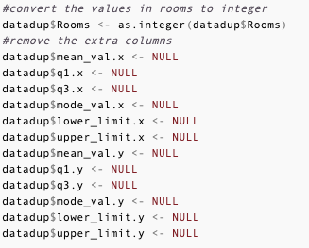

Figure 20: Data type conversion and remove extra info.

Number of rooms cleaned by first setting all data to lowercase, then an extra column is created to use the additional rooms specified in number of rooms, where “+1” populates the extra_rooms column with 1; “+2” populates with 2, otherwise populate with 0.

Then gsub() removes all extra rooms data by removing all patterns of + and afterwards, removing the word above, and replacing studio records with 1 number of room then converting all room data to numeric.

After that a function is defined to get the mode of the column, used when getting the summarized information of room and price. Both are left joined into the data frame and used to conditionally impute the missing rooms value.

Lastly, all the rooms data are converted to integer and the price and room summary columns are removed.

# 3.0 Data Analysis

## 3.1 Objective 1: To investigate the relationship between number of car park and property price.

The are several analysis techniques being used among these three analyses. Descriptive statistics is implemented where the mean of carparks, and property prices is being calculated. Data visualisation implemented by Lollipop Chart, Linear Regression, and Strip Plot. Data Manipulation uses ‘dplyr’ packages to filter, and a subset for aggregating and manipulating the dataset for analysis and visualisation.

### **Analysis 3.1.1 How does the average property price vary with the number of car parks available?**

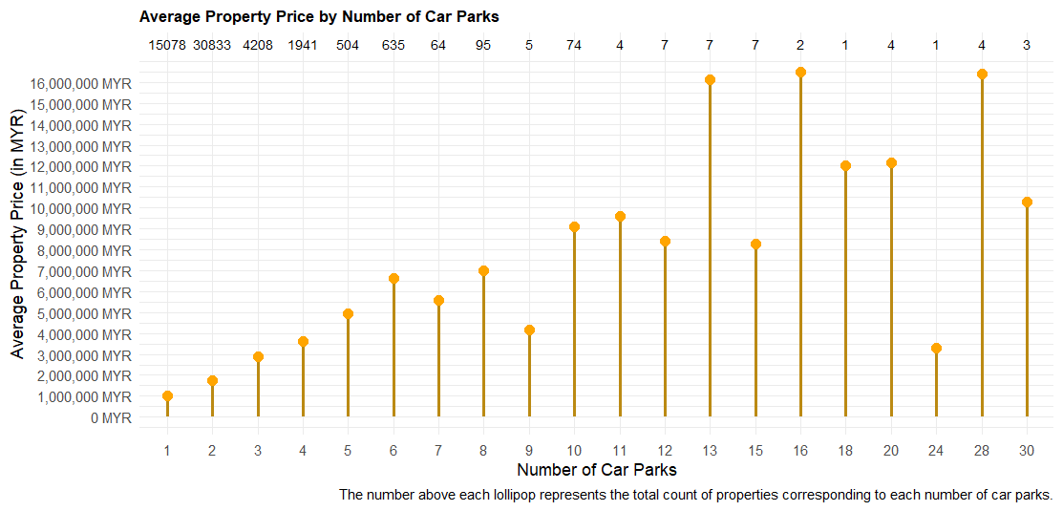 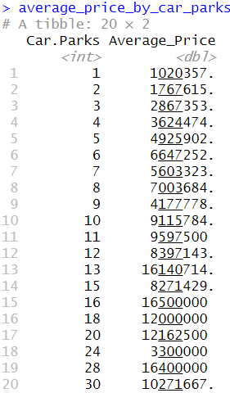

Figure 21 Lollipop chart to find average property price by counting number of carparks.



Figure 22 Number and percentage of property more than 13 carparks.

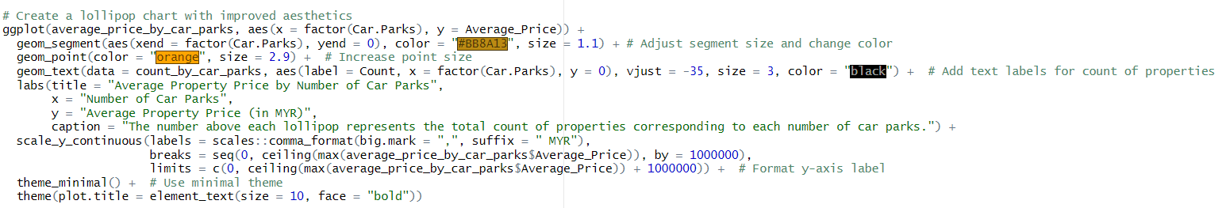

Figure 23 Lollipop chart code.

Extra Feature: Lollipop chart – geom_point(), geom_segment()

Type of Analysis: Descriptive Analysis, Statistical Analysis

The KL property dataset is being visualised by using a lollipop chart which shows the clear relationship between the number of car parks and average property prices. When the number of car parks increases, the average property price also increases, suggesting a correlation between parking availability and property value. While most properties have 1 or 2 car parks, fewer properties offer higher numbers of car parks as the count increases. There are outliers in the dataset where there are properties with exceptionally high prices. For example, a property with 13 carparks requires an average of RM16,140,714, but a property that provides 15 carparks only requires an average of property price RM8,271,429. In the dataset, the property that provides 12 car parks and below is the higher the property price, the greater the number of car parks provided. However, when it comes to 13 car parks and more, the property comes with exceptionally high prices. The high property price could be considered a unique condition, as properties that can provide such a high number of car parks are uncommon. Additionally, the dataset only contains 29 properties that provide more than 13 car parks, representing a percentage of 0.04% of the KL properties dataset. Therefore, investigating the high price of these outliers should consider other factors such as location, property size, amenities, and so on. A lollipop chart is used to visualise the extreme values and make it easy to compare the magnitude of the price of different numbers of car parks.

### **Analysis 3.1.2 Can the number of car parks predict property prices, and if so, what is the regression equation that best describes this relationship?**

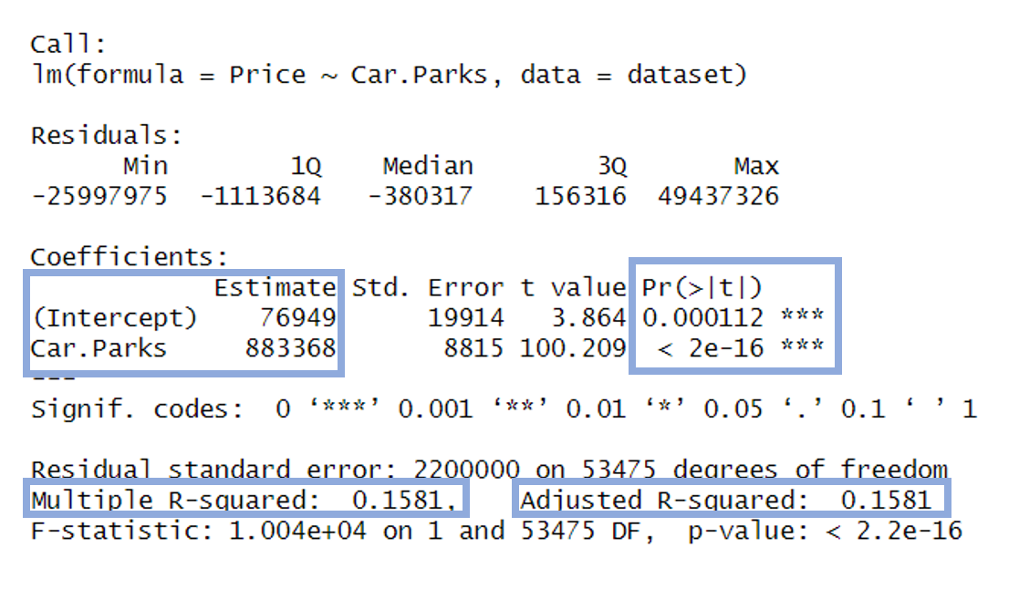

Figure 24 Summary of regression analysis.

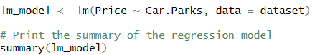

Figure 25 Regression model code.

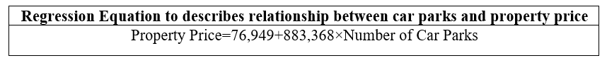

Extra Feature: Regression analysis – lm();

Type of Analysis: Diagnostic analysis, statistical analysis, predictive analysis.

**Null Hypothesis:** The number of car parks does not affect property prices.

**Alternative Hypothesis:** The number of car parks does affect property price.

The regression analysis is implemented to quantify the relationship between the number of car parks and property prices by providing statistical measures of significance, and prediction capability and enhancing the accuracy and reliability.

The regression equation is created based on the coefficient intercept value and coefficient number of car parks. The equations indicate that for each additional car park, the property price is expected to increase by approximately RM883,368. It shows that parking availability significantly influences property prices in the KL market.

In the KL property dataset, both the coefficient for Car.Parks and intercept coefficient are statistically significant, with the p-values (< 2e-16) lower than 0.05. Based on the p values, we can conclude that null hypothesis will be rejected and accept the alternative hypothesis. This shows that the number of car parks does affect the property price.

The R-squared value of 0.1581 indicates that only a very small proportion of the variance in the property prices is explained by the number of car parks. A low R-squared values show that the car parks are important, but the number of car parks is not the only factor that affects the property prices in KL. Not only that the adjusted R-squared value of 0.1581 also indicates the model’s predictive power is limited. This shows that the number of car parks is a significant predictor, but other factors like location, and property size, which aren’t included in this model may also influence property prices in KL.

### **Analysis 3.1.3 What is the relationship between property prices and the number of car parks provided, considering different property types?**

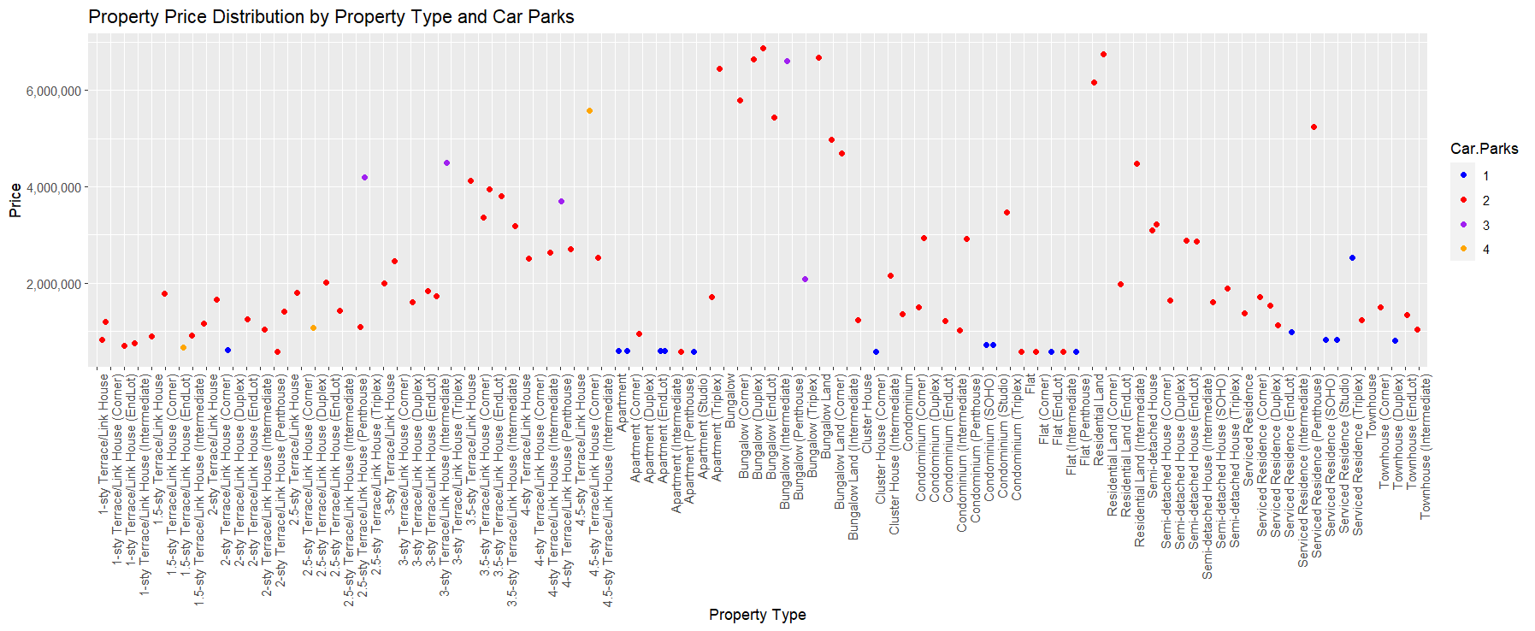

Figure 26 Strip plot visualisation for finding price against property type and carparks.

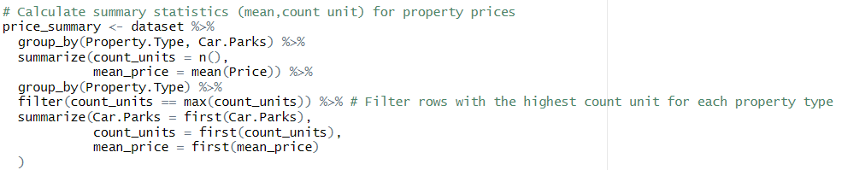 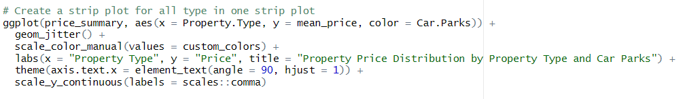

Figure 27 Strip plot code.

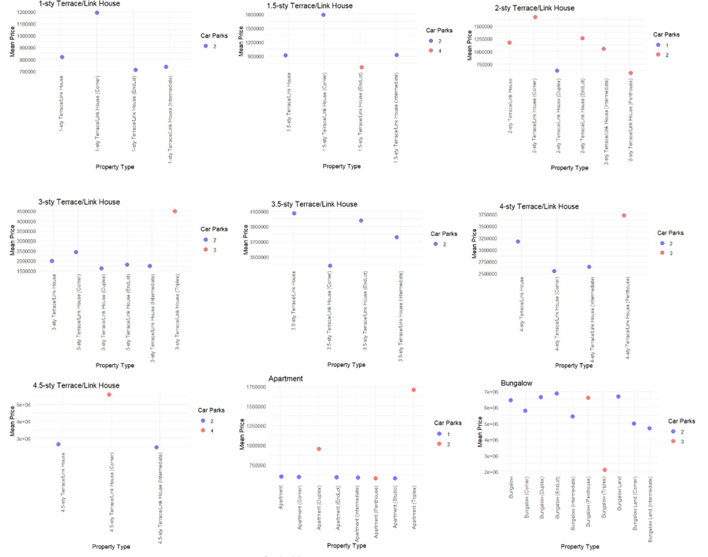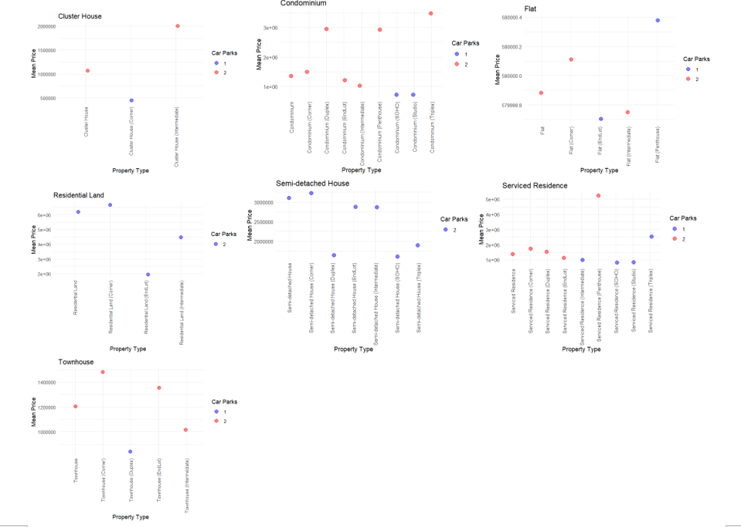

Figure 28 Strip plot implementation for each property type.

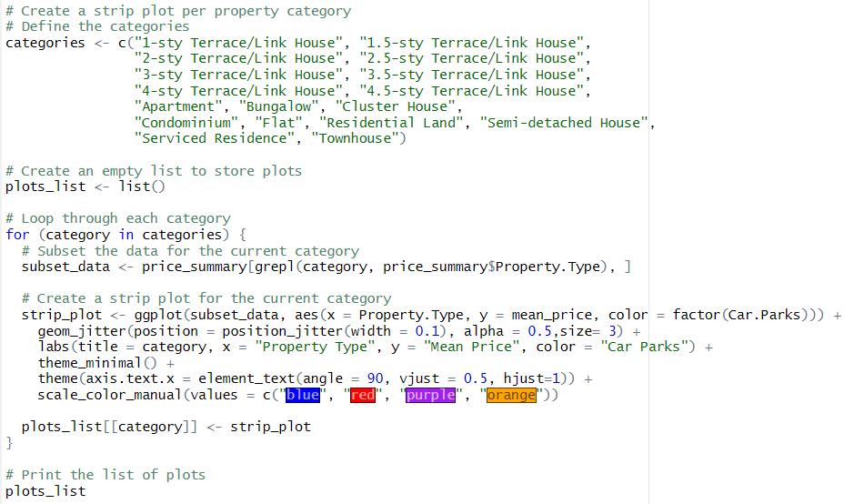

Figure 29 Each property type strip code implementation.

Extra Feature - Strip plot – geom_jitter();

Type of Analysis: Descriptive analysis, Statistical Analysis

The strip plot compares the average prices of different property types and the number of car parks provided. Each dot represents the average price (mean) of the property type, and the colour represents the number of car parks.

The strip plot reveals that in Kuala Lumpur, most properties offer a range of car parks from 1 to 4. Specifically, the majority of 4.5-sty Terrace/Link Houses (Corner) provide the most car parks, typically offering 4 parking slots. However, most properties in KL tend to provide 2 to 3 car parks.

When analysing the relationship between property price and the number of car parks provided by including property type, the results suggest that there isn't a significant correlation between the two variables. This finding contrasts with the discussion in analysis 1.1, which suggests that as the price of a property increases, more parking spaces are typically provided.

Each category of property type has one strip plot shows that each category has similar property prices and provides a similar amount of car parks. According to the findings, when it includes another factor, the property price and parking don’t have a positive relation. However, when it only compares property prices and the number of car parks, it has a positive relation with the number of parking 13 and below.

Implementing a strip plot can improve the accuracy of analysis by visually displaying the distribution of property prices across different property types and parking, allowing for the identification of penitential trends, and patterns within each property category.

### **3.1.4 Conclusion**

Most of the properties in KL only provide 2 to 4 car parks. When analysing the dataset in general, the result obtained is that if you pay more, you will get more car parks. However, when we dive deeper to investigate the relationship between property prices and the number of car parks, there is no significant data showing that higher property prices lead to more car parks being provided. Instead, when other factors like property type are included, it becomes evident that the property price and number of car parks provided are similar across each other in the same category of property type. It can be concluded that the property price and number of car parks will only have a positive relationship if other factors are not considered. Once other factors are included, the property price and number of car parks are similar to each other within one category. Suggestion for the stakeholders is, that they should focus on property type, consider the location, then only focus on the number of car parks where it should provide 2 to 4 carparks per property.

## 3.2 Objective 2: To investigate the relationship between property price and location.

### **Analysis 3.2.1: Which location possesses the highest price and the lowest average property price?**

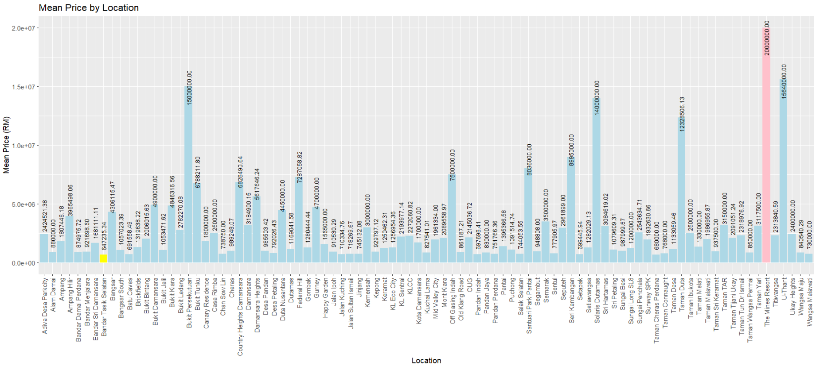

Figure 30: Column graph Mean Price vs Location.

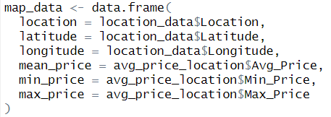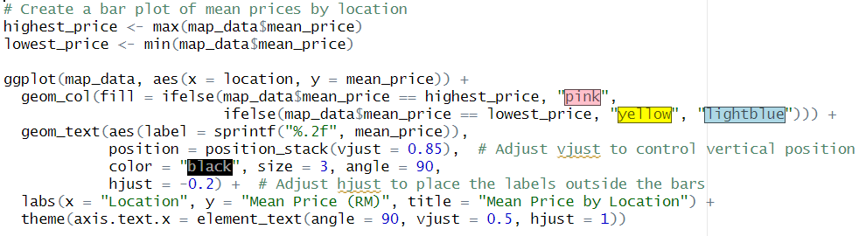

Figure 31: R code to generate column graph above.

**Descriptive analysis** is conducted. The location data is grouped, and the mean price is calculated. A column graph is plotted to compare the mean property price in each location. The location with the highest and lowest price is coloured with pink and yellow respectively. The result shows the location with the highest mean price is The Mines Resort, which is RM 20,000,000. The location with the lowest mean price is Bandar Tasik Selatan, which is RM647,235.34.

### **Analysis 3.2.2: What is the cluster patterns of property price range based on location?**

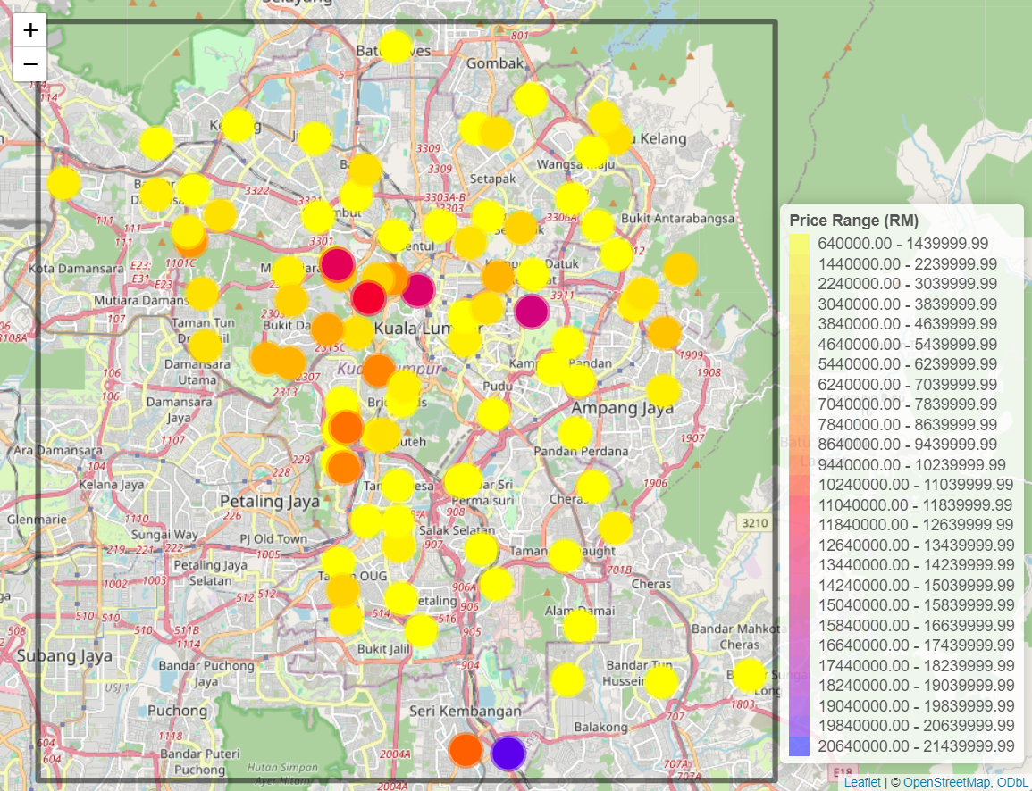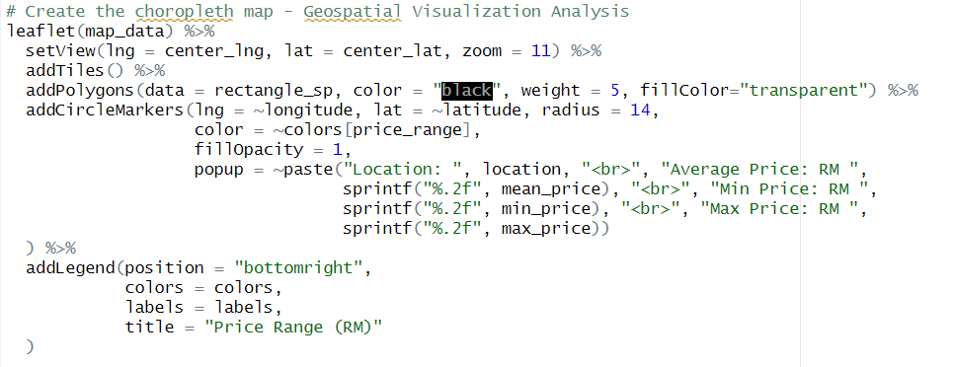

Figure 32: Leaflet map and its R code.

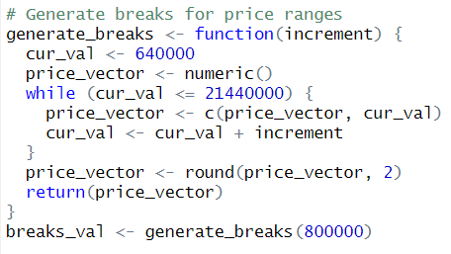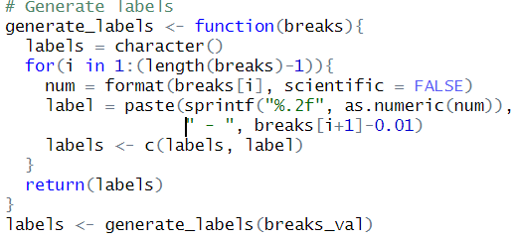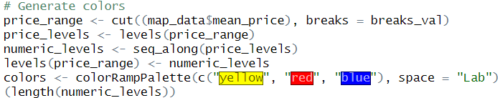

Figure 33: R code to generate price range, labels and colours.

**Geospatial data analysis** is applied in this research to analyse and visualize how the property price ranges are distributed in Kuala Lumpur area (R CODER, 2024). Kuala Lumpur map is imported, and the locations are plotted using circle markers onto the map. The mean prices are divided into a few price ranges. The colour gradient transitions from yellow to red to blue to visually represents the variation in price ranges across different locations. A pop up can also be shown when clicked on the marker to display its location name, average, min and max price.

According to the plotted map, the areas around Damansara, KLCC, Bangsar and The Mines Resort area possess higher price range. On the other hand, the areas near Bandar Tasik Selatan, Kepong and Pandan Indah Area possess lower price range.

### **Analysis 3.2.3: Do adjacent locations have similar property price range?**

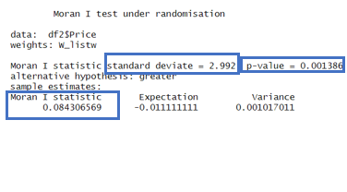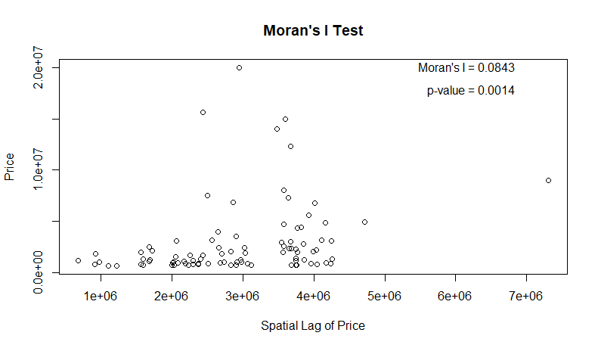

Figure 34: Moran’s I Test Summary and Graph

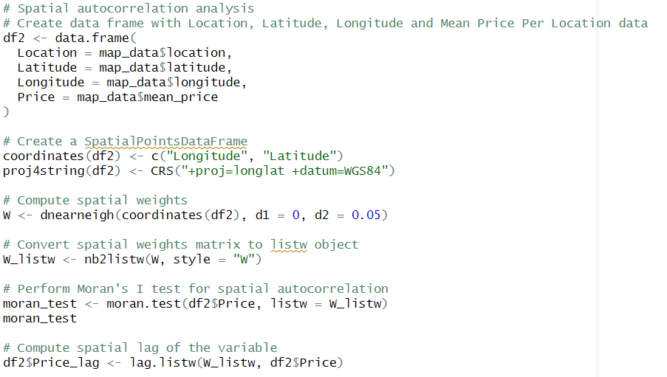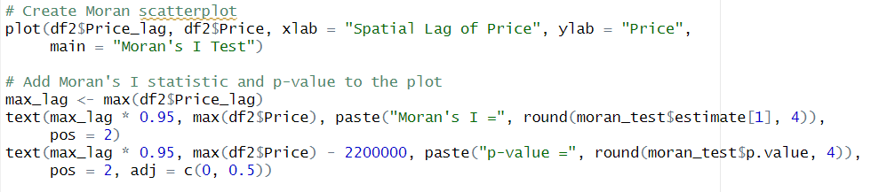

Figure 35: R code for Moran’s I Test

**Moran’s I test** is implemented in this study to explore the spatial autocorrelation in data, particularly to identify whether neighbouring locations exhibit similar property price ranges (Bivand, n.d.). The resulting Moran I statistic standard deviate of 2.992 indicates a significant positive spatial autocorrelation. Moreover, its p-value is 0.001386, which is lower than the chosen significance level of 0.05, showing that there is a significant spatial autocorrelation in property prices. Furthermore, the Moran’s I statistic value is used to determine the spatial pattern of the given data. Positive Moran’s I represents the positive spatial correlation, meaning similar values tend to cluster together while negative Moran’s I represents negative spatial correlation and vice versa. For the Moran’s I statistic close to 0, it represents no spatial autocorrelation. As the Moran’s I value is 0.0843, it indicates a weak positive spatial autocorrelation in property prices. In conclusion, the output suggests that there is a statistically significant positive spatial autocorrelation in the dataset, meaning that adjacent locations do have similar property price range.

### **Analysis 3.2.4: Does the distance of each location from the heart of Kuala Lumpur (KLCC) affect the property price?**

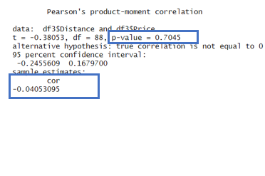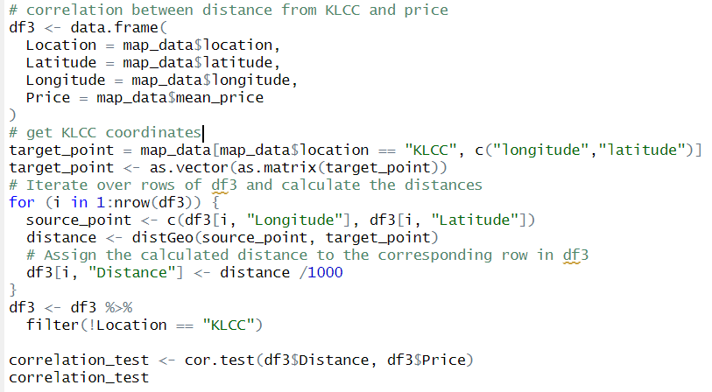

Figure 36: Correlation Summary Figure 37: R code for correlation test.

The distance between each unique location and KLCC is computed, and the **correlation analysis** is conducted. The result is -0.0405, indicating a weak negative correlation. As the p-value is 0.7045, which is greater than 0.05 and the confidence interval includes zero, supporting that there is no significant correlation between the distance of each location from KLCC and property price. Therefore, it summarises that the correlation between these two variables is weak and not statistically significant.

### **3.2.5: Conclusion**

In conclusion, the hotspots such as Damansara, Bangsar and so on usually offer more well-developed infrastructure such as shopping malls, restaurants, entertainment venues and better transportation networks such as LRT, MRT and buses. Besides, there are more job and business opportunities around those areas, which attracts the people to live closer to the areas mentioned to reduce the commuting distances to work. This increases the demand of houses in relevant areas, causing the property price also increased. Based on the analysis, the places close to KLCC does not necessarily have higher property price If a location offers attractive features such as convenience and job opportunities, it tends to become a hotspot with higher property prices. Besides, it is found that the property price range tends to be similar in adjacent locations.

### **3.2.6 Extra Features**

#### 3.2.6.1 Location Coordinates

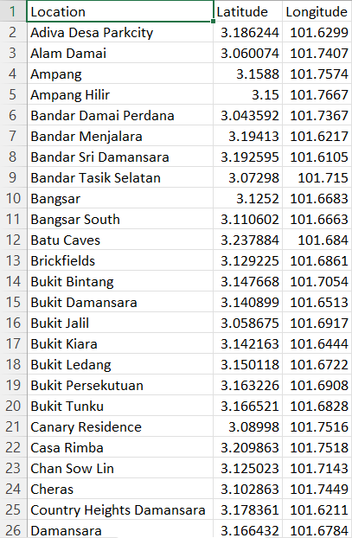 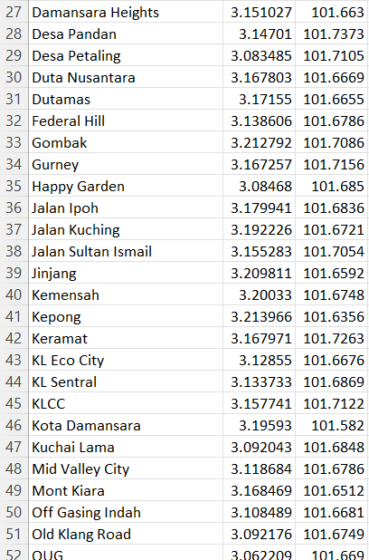 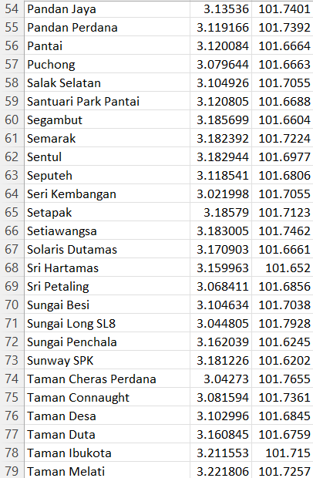 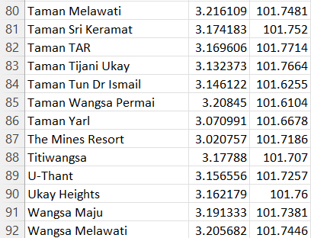

Figure 38: Location Coordinates

The coordinates of each unique locations are found for map plotting and distance finding purposes (Postcode.my, 2024).

#### 3.2.6.2 Polygon Object

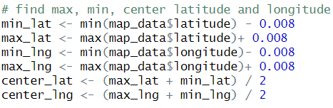 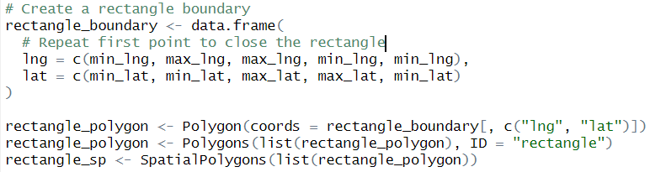

Figure 39: R code for polygon objects.

The coordinates of the boundary are found. “Polygon()” defines the coordinates of boundary. “Polygons()” make the coordinates a list. “SpatialPolygons()” makes the list into SpatialPolygons object to be used as a boundary in the map.

#### 3.2.6.3: Leaflet



Figure 40: R code for Leaflet

Leaflet library is implemented to visualize the relationship between locations and property price ranges. SetView() zooms the map; addTiles() adds a base map layer; addPolygons adds boundary; addCircleMarkers plot the locations on the map; addLegend adds price range labels to the map.

#### 3.2.6.4 Moran’s I Test

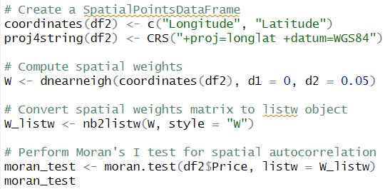

Figure 41: R code for Moran’s I Test

Spatial coordinates are created using the longitude and latitude in df2. Proj4string sets the coordinate reference system(CRS) of spatial object df2 to WGS84, which is a commonly used geographic coordinate system. Dnearneigh() creates a matrix where observations within a distance of 0 to 0.05 decimal degrees, approximately 5.5 kilometers at the equator are considered neighbours. Nb2listw converts W to listw object so that it can be used to perform moran test.

#### 3.2.6.5 DistGeo

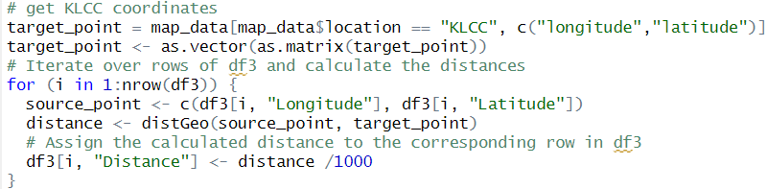

Figure 42: distGeo.

The distance between KLCC and each unique location is calculated using distGeo function from geosphere module.

## 3.3 Objective 3: To investigate the relationship between number of rooms and property price.

### **Analysis 3.3.1 How does the number of rooms of a property in KL influence the price of a property?**

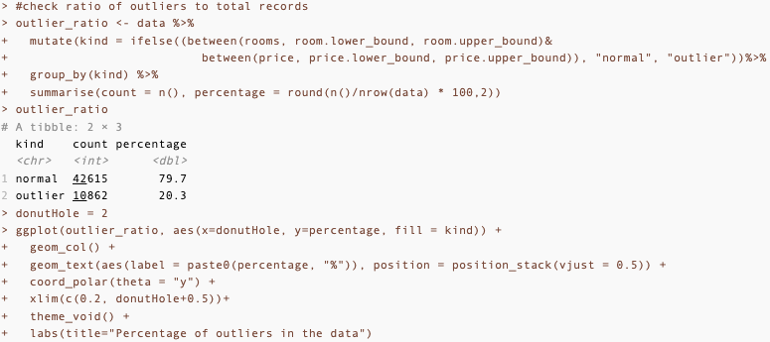

Figure 43: Code for generating Donut chart.

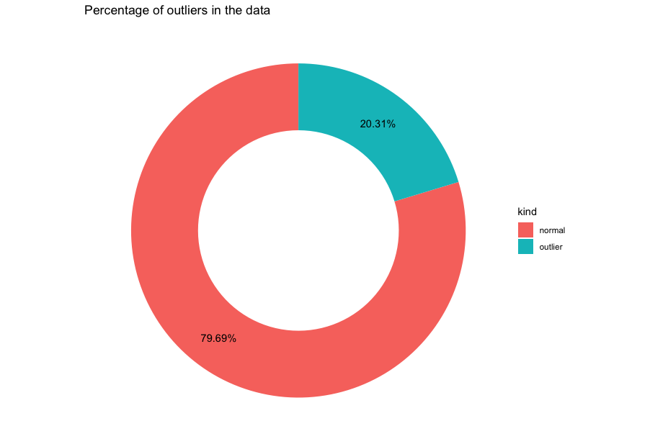

Figure 44:Outliers percentage donut chart.

Extra feature 1: Donut chart (R CODER, 2024)

**Outlier detection, Diagnostics Analysis:** First we will check for the percentage of outliers within number of rooms, recognizing the size of outliers in a dataset can help us determine how much of the data we use is expected to fall out of the normal range and become unpredictable. Based on the donut chart of outliers to normal there is a 4 to 1 ratio of normal data to outliers. Although the percentage of outliers are quite minor, it does make quite a difference when it comes to analysing a dataset with around 50 thousand records. So, the number of rooms will be analysed both with only normal values and with outliers.

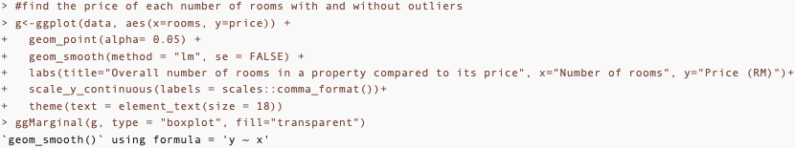

Figure 45: Code to generate scatterplot

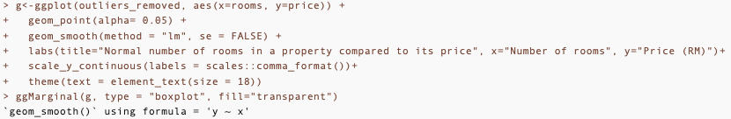

Figure 46: Code to generate scatterplot with outliers removed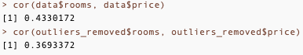

Figure 47: Code and output for correlation between rooms and price

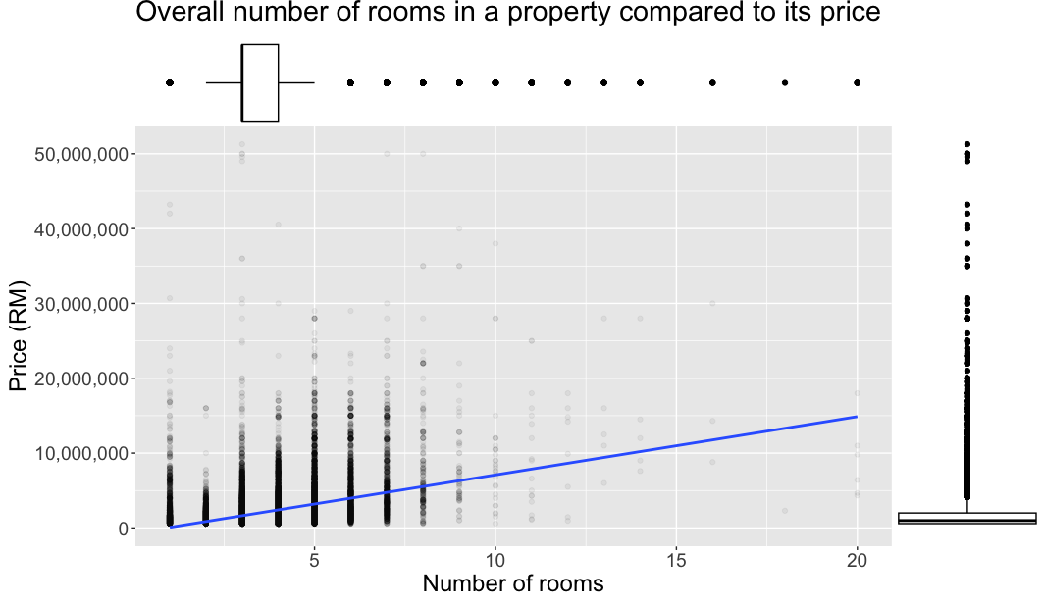

Figure 48: Scatterplot.

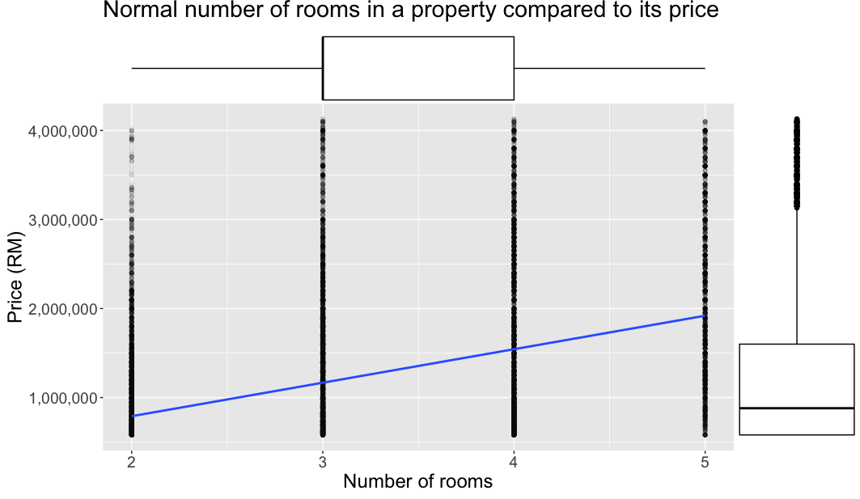

Figure 49: Scatterplot with outliers removed

Extra features 2 ggMarginal() (Prabhakaran, 2017)

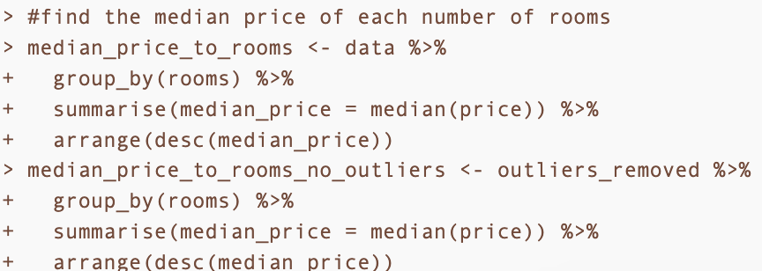

Figure 50: Code for median price to rooms.

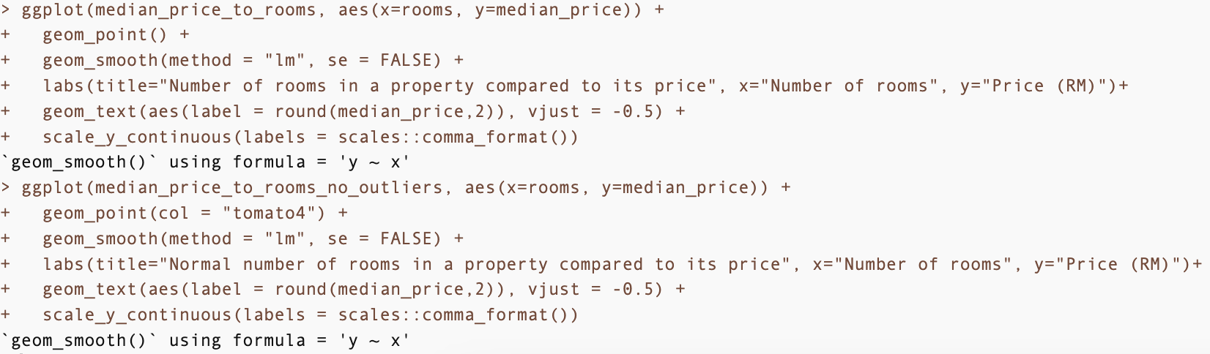

Figure 51: Code to create chart using median price.

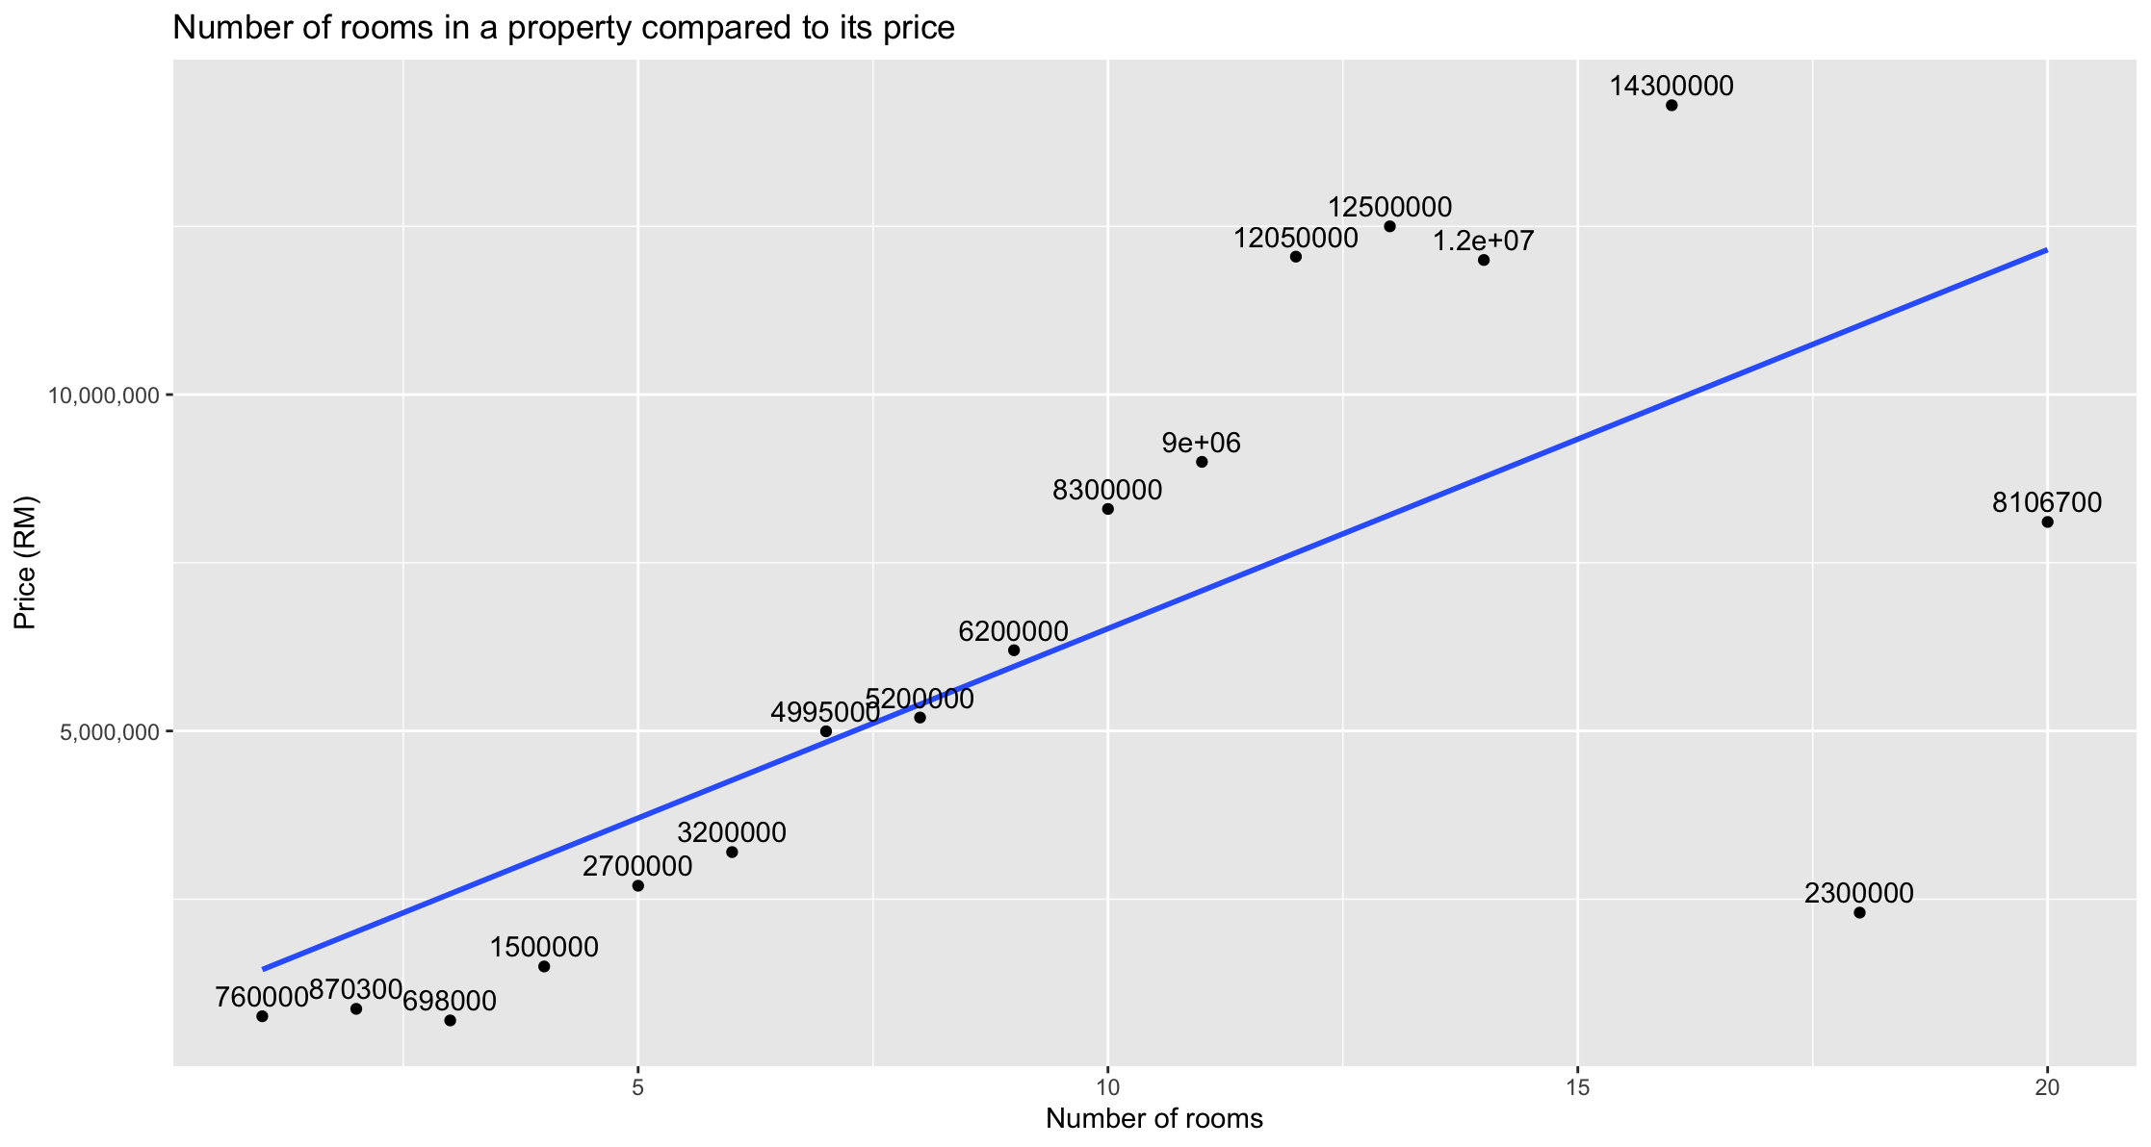

Figure 52: Median price chart.

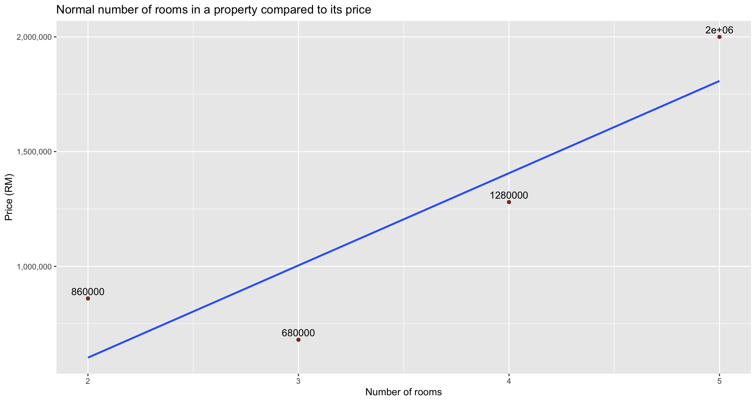

Figure 53: Median price chart without outliers.

**Descriptive analysis**: A combination of scatter plot, linear regression line and box plot is used to identify different aspects of the relationship between price and number of rooms. The box plot is used to find out the distribution and normal range of values, whereas the scatter plot and linear regression line is used to identify the correlation between price and number of rooms.

Based on the distribution and linear regression line on the graph from both scatterplots. The number of rooms range from 1 to 20 overall and 2 to 5 when specified for the normal range with a mode and median of 3 rooms per property. The number of rooms has a positive but weak correlation with price , this is also evident when using the “cor()” function returned a value of 0.3 to 0.5 for normal and overall datasets.

But if we compare it based on the median price of each number of rooms, we can clearly see an upward trend in our data, with the lowest median price being from 3 number of rooms.

### **Analysis 3.3.2** **Are there any special cases (outliers) where specific number of rooms have a lot more expensive price than the average?**

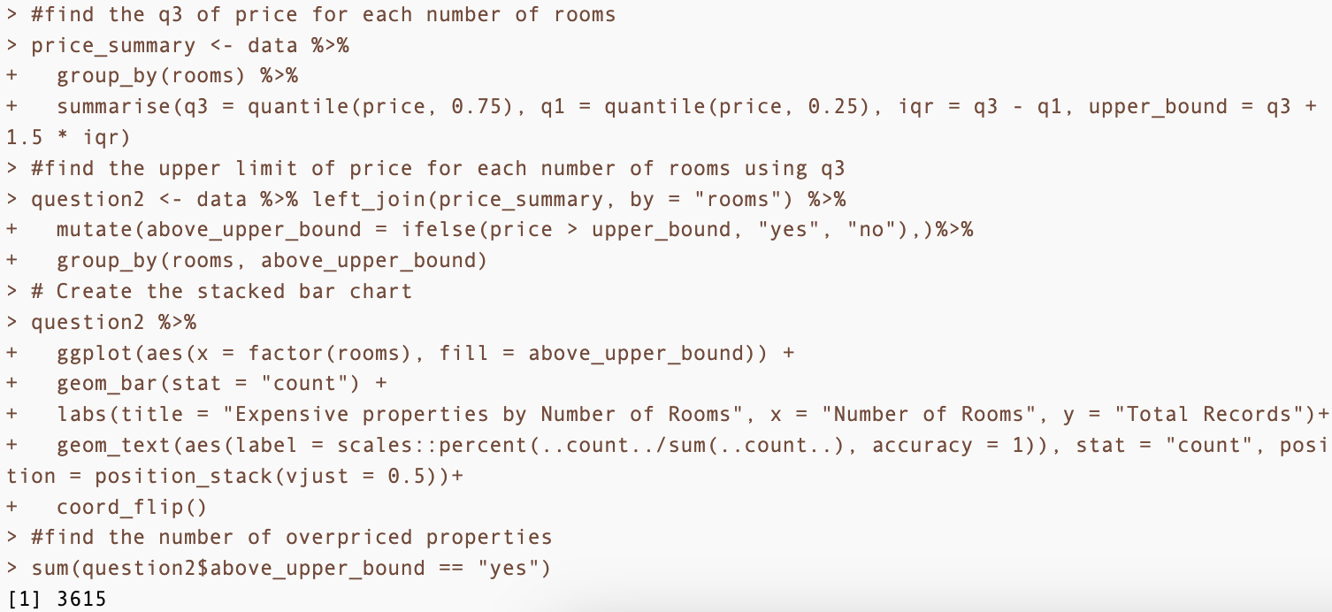

Figure 54: Code to check property with unusually high prices.

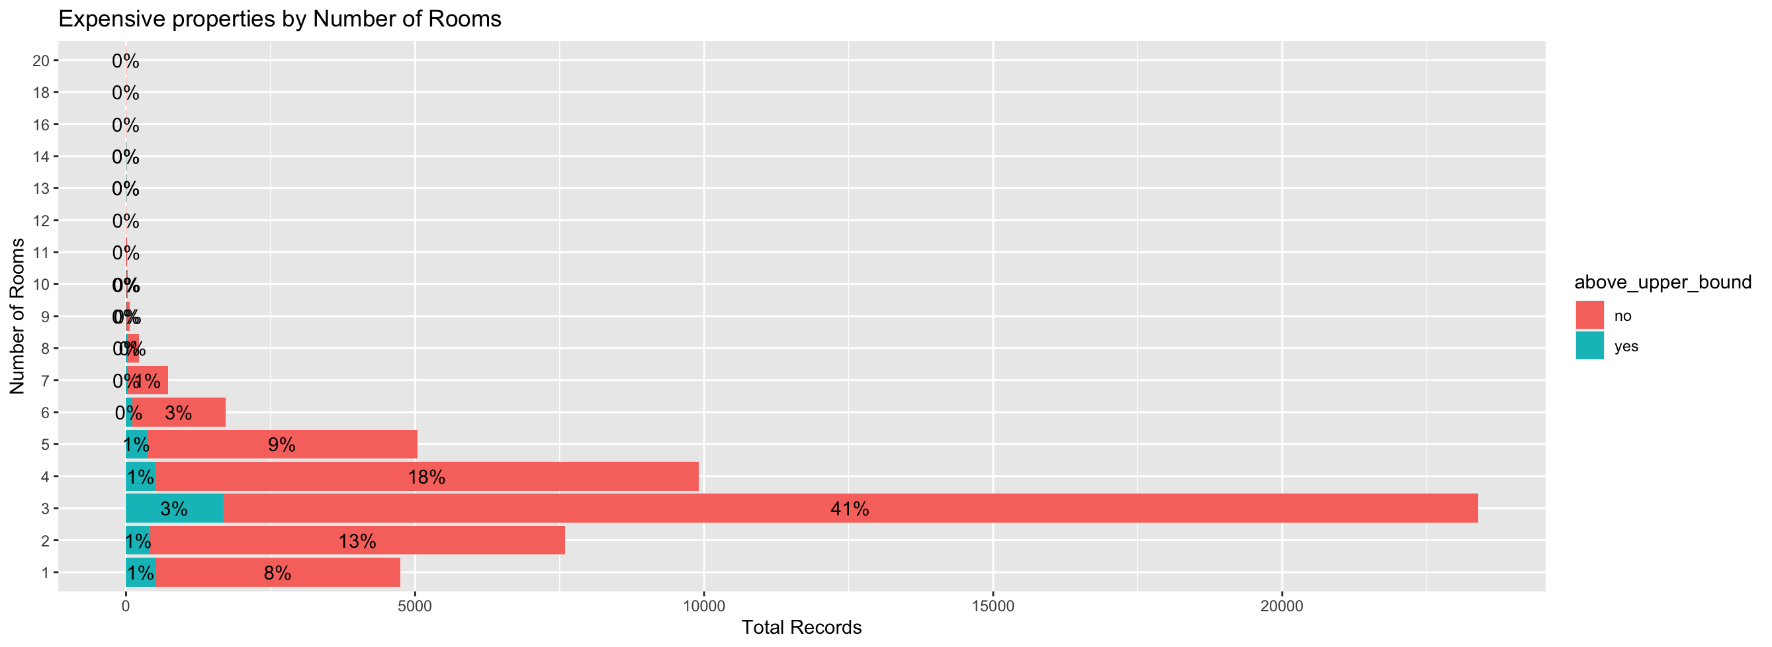

Figure 55: Chart comparing property with unusually high prices.

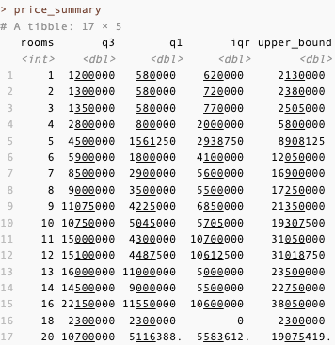

Figure 56: Price summary according to number of rooms.

**Diagnostics analysis, prescriptive analysis, statistical analysis:** To find out the amount of records where it has unusually high prices for each number of rooms, we need to first find out about some information on the measures of central tendency related to the price for each number of rooms, specifically, the 1st quartile, 3rd quartile, interquartile range, and upper bound. This information will be useful to determine a preferrable property for purchase based on its 3rd quartile and upper bound for its number of rooms. Then, we can combine this information with our main dataset by left-joining them by the number of rooms and derive a new identifying column to check if the record is an unusually expensive property. Lastly, we use this identifier column to sum up exactly how many of these unusually expensive records are in the dataset and plot a stacked bar chart to show how much of it exist in comparison to the normal data. Based on the outputs of this dataset, there are around 3615 properties with unusually high price, which comprises of 7 percent of the entire dataset in general.

### **Analysis 3.3.3 Does the presence of extra rooms have any significant effect on the properties price?**

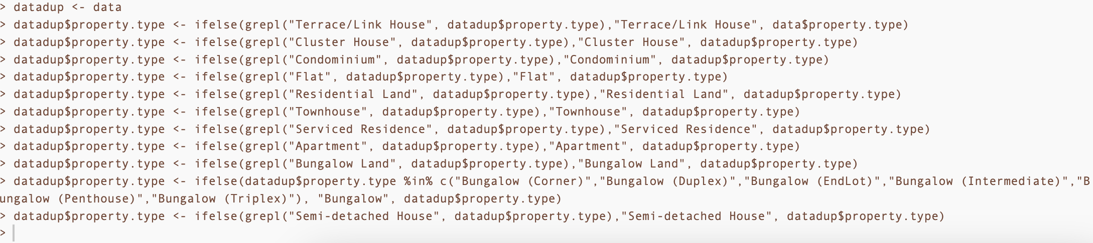

Figure 57: Generalizing all property subtypes.

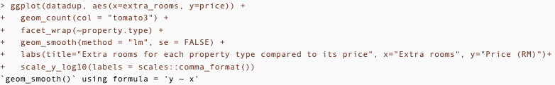

Figure 58: Code to generate count plot faceted by property type.

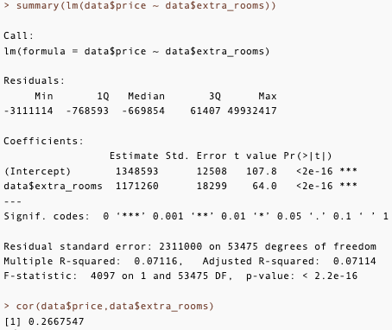

Figure 59: Linear regression model to predict property price based on extra rooms.

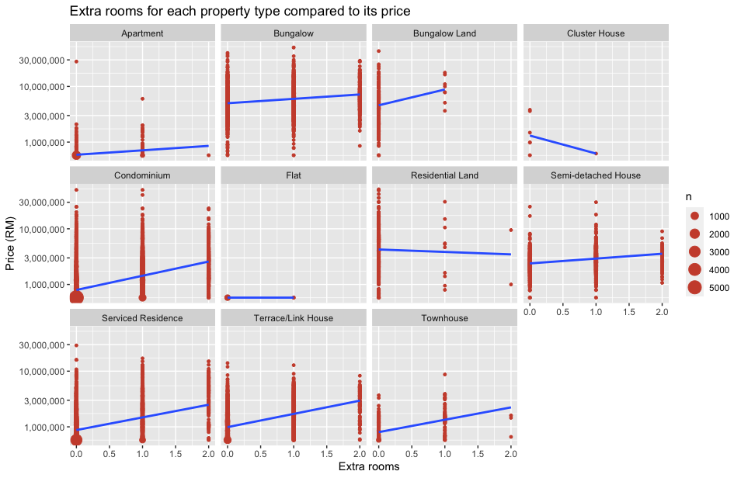

Figure 60: Count plot faceted by property type.

Extra feature 3: Count plot~geom_count() (Prabhakaran, 2017), lm()

**Correlation analysis, predictive analysis:** Since there are too many property types, a duplicate dataset is first used to consolidate all the subtypes for each property type from 98 to 11 types. Then based on that data, a count plot faceted by the consolidated property types are used to visualize the patterns and correlation between the existence of extra rooms and the effect it has on its price. In add According to the count plot, there is a weak positive correlation across most of the property types shown in the faceted count plot. There is also a negative correlation observed in cluster houses due to a lack of cluster house property types in the dataset.

Other than estimating the correlation with the linear regression line from the graphs and the cor() function, extra rooms is further tested with a linear regression model to explore its regression coefficient, the summary revealed a statistically significant relationship between property prices and the number of extra rooms. The intercept was estimated at 1,348,593, indicating the predicted price when the number of extra rooms is zero. The coefficient for extra rooms was 1,171,260, suggesting an estimated increase in price for each additional room. Both coefficients demonstrated high statistical significance with p-values as low as < 2e-16. The model explained approximately 7.12% of the variability in property prices (R-squared = 0.07116). This information provides valuable insights for predicting property prices based on the number of extra rooms, contributing to a more comprehensive understanding of the dataset.

### **3.3.4 Conclusion:**

The properties in KL normally have rooms ranging from 2 to 5 with the most common values among number of rooms being 3 to 4 rooms. Although the correlation is weak, the number of rooms do in fact increase with the price of the property. The number of rooms with the lowest price is 3 suggesting the favourability of houses with around the same number of rooms for the majority of residents in KL. Next, among the properties in KL, only around 7% or 3615 of them have a higher than normal price according to their number of rooms. And although the correlation of extra rooms on the price of a property is very weak, it has significant predictive power for property price.

## 3.4 Objective 4: To investigate the relationship between property size and property price.

### **Analysis 3.4.1: How is the property price and property size correlated?**

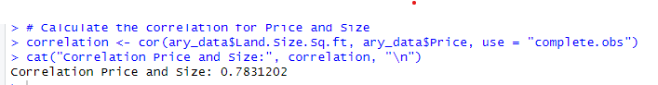

Figure 61: R-Script Correlation Calculation

**Type of analysis: Descriptive analysis and Predictive analysis**

A **descriptive and predictive analysis** were conducted to determine the correlation between Price and Size is calculated using the “cor()” function which included only complete pairs of observations, excluding any rows where either size or price had missing values. In this case, the correlation coefficient is 0.7831202 which is close to 1 indicates a strong positive linear relationship. This can be understood that as the **property size increase, the property price increase.**

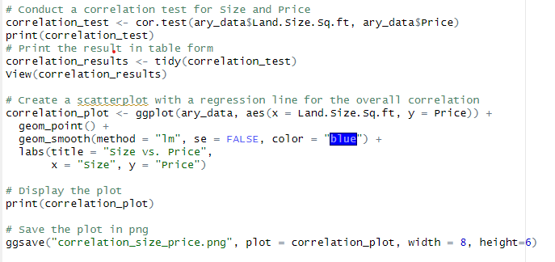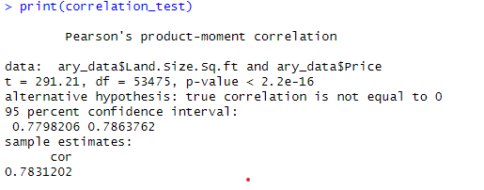

Figure 62: Correlation Test Figure 63: Result.

**lm(), cor.test(), ggsave() (Extra Features)**

Additionally, a correlation test is conducted by using the **“cor.test()”** function to assess the statistical significance of the correlation between property size and property price (STHDA, n.d.). The **null hypothesis** for this test **assumes that there is no correlation between the property size and the property price**. The table shows that the correlation coefficient is 0.7831202, the t-value which measures the strength of relationship between property size and property price, is 291.23 and a result of p-value less than 2.2e-16 indicating a strong evidence against the null hypothesis that the true correlation is equal to 0. The findings of the result supports the existence of a significant positive correlation between property size and property price. **“lm()”** function is used to create a linear regression model, where in this case it predicts the price where size is the predictor variable (Codecademy, n.d.). **“ggsave()”** function is used to save the ggplot as a file (ggplot2, n.d.).

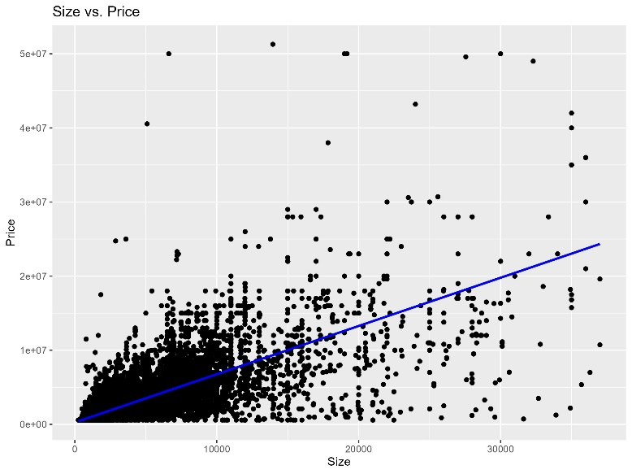

Figure 64: Scatter plot with regression line

The figure shows the visualisation of the correlation by plotting a scatter plot with regression line to indicate the positive correlation between property size and property price.

To further explore the relationship between Price and Size, we can also predict price of size more than current maximum size.

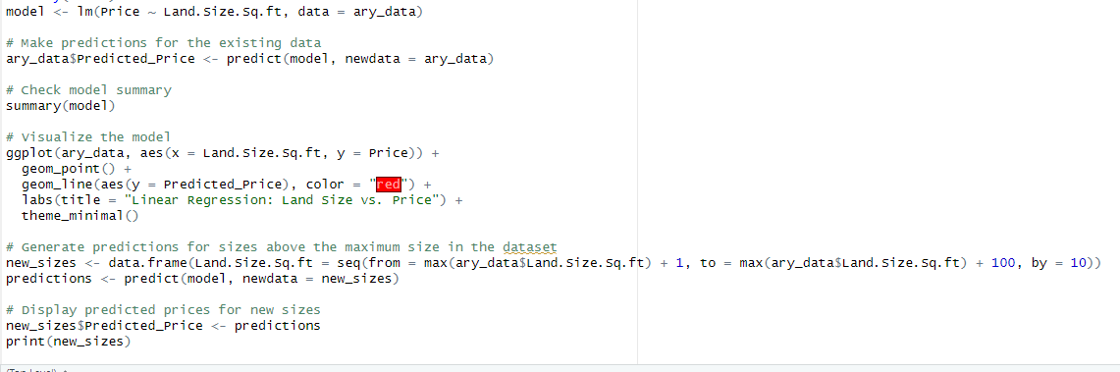

Figure 65: Predict Price

A linear regression model is created using “lm()” function which fits a linear model to the data. A scatter plot with regression line is used to visualise the model. Predictions for new sizes above the maximum size is generated and stored in the dataframe “new_sizes()”. Predictions generated by using the “predict()” function based on the model.

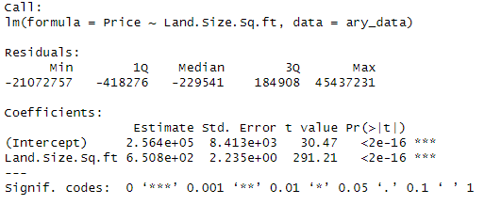

Figure 66: ANOVA Test Result

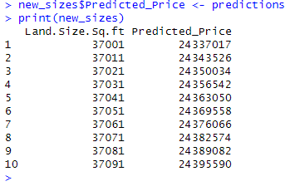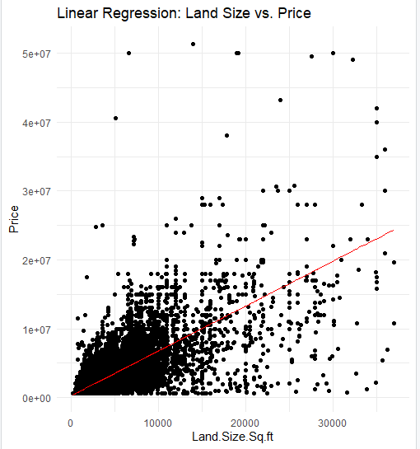

Figure 67: Result for predicted price.

In the chart above, the red regression line shows the predicted price, and the predicted price above current maximum size is listed out.

### **Analysis 3.4.2: What range of the property size contributes to higher cost in property price?**

**Type of analysis: Prescriptive**

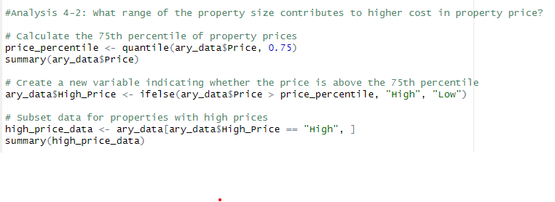

Figure 68: Filtering price higher than 3rd quartile as expensive.

Through this analysis, the findings can be used to make **suggestions** to people who have a budget in mind to determine which property to buy, involving the **prescriptive analysis**. The price that is above the 3rd quartile of property price is set as High cost of property price. A new variable “High_Price” categorises the property price into “High” or “Low” based on whether the price exceeds the 3rd quartile. The data then subset into another data frame “high_price_data” which holds the data that only has “High” based on the “High_Price” variable.

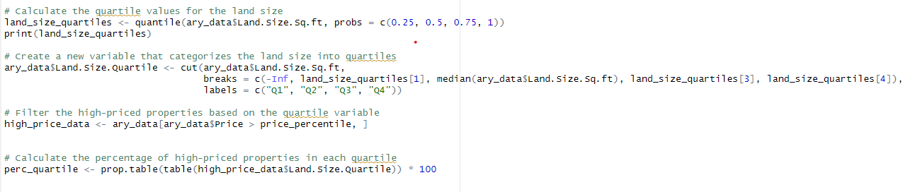

Figure 69: Filter Range of Size based on Quartiles.

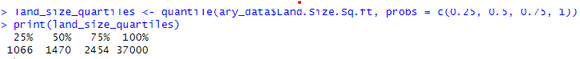

Figure 70: Quartiles of Property Size

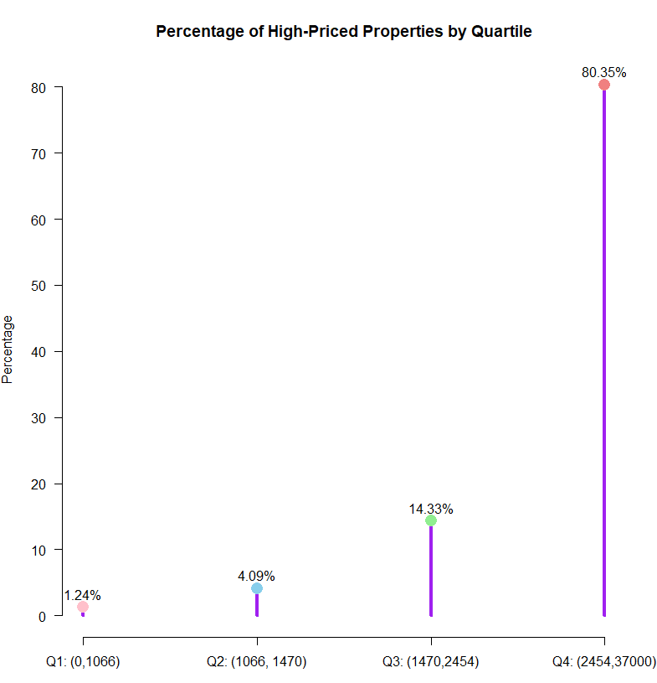

Figure 71: Lollipop chart.

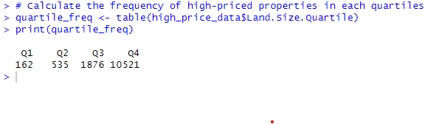

Figure 72: Number of properties in each quartile.

The land size variable was divided into range which is known as quartiles (Q1 to Q4) in this case by using the ‘probs’ parameter in the ‘quantile()’ function which specifies the quantiles to be computed. The calculated frequency of every quartile is shown in form of table. Through the lollipop chart and table, we found that the size range in Q4 which is from 2454 sq ft to 37000 sq ft contributes to higher cost in property price.



Figure 73: R-Script to create Lollipop Chart.

A lollipop chart is created to visualise the percentage of high_priced properties in each range (quartile).

### **Analysis 3.4.3: Does the common average size of the condominiums in Kuala Lumpur have similar prices?**

**Type of Analysis: Analysis of variance, hypothesis testing**

Property type impacts the property size and price, and different property types have different size ranges, and the size of a property can affect its price. Therefore, in this analysis, condominiums are chosen to be analysed as it is the most common property type across Kuala Lumpur.

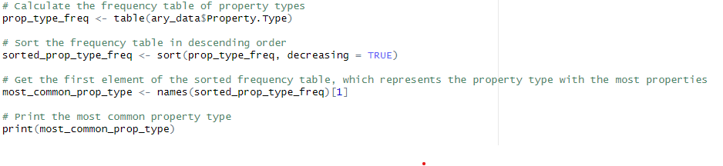

Figure 74: Checking the property type with highest frequency.

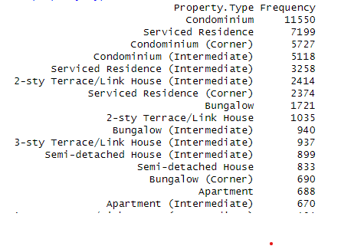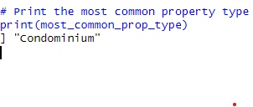

Figure 75: Result.

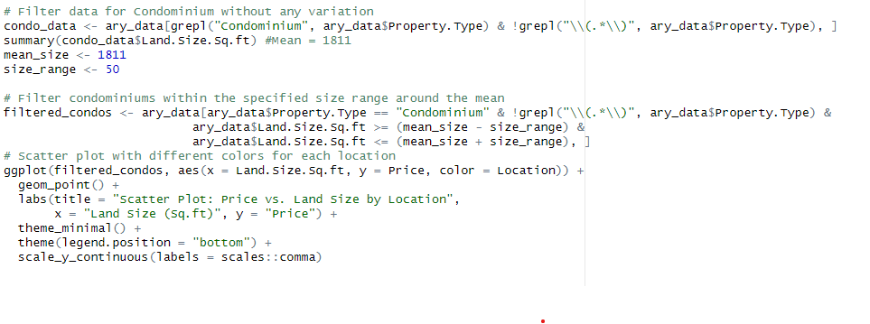

Figure 76: Filtering Condominium with similar mean.

**scale_y_continuous(labels = scales::comma) (Extra Features)**

The code **scale_y_continuous(labels = scales::comma)** formats the Price number in y-axis with commas as thousand separators, making it easier to read (ggplot2, n.d.).

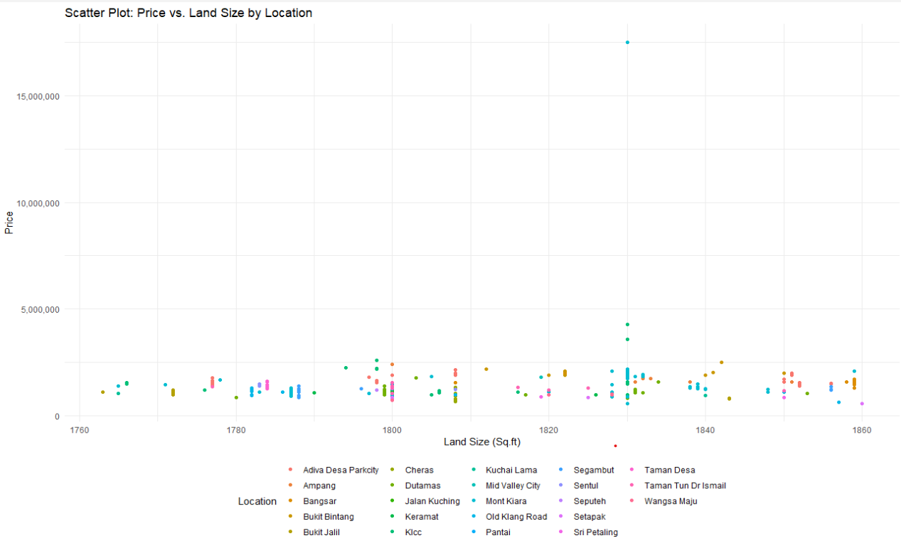

Figure 77: Scatter Plot of Price vs Size by Location

The dataset is first being filtered and subset into a data frame “condo_data” which stores the data for Condominium with no other variations of Condominium. Given the mean size is 1811, the range plus minus of 50 sq ft is given to determine the common average size of the condominium. Based on the scatter plot, we can see that the common average size of condominium does not have similar prices.

Additionally, an analysis of variance (ANOVA) test which is a type of hypothesis test is used for comparing means of more than one groups (STHDA, n.d.). It is used to further determine if the mean property prices with the common average size of condominiums are same in Kuala Lumpur.

**Null Hypothesis:** The mean property prices with the common average size of condominiums are equal in Kuala Lumpur.

**Alternative Hypothesis:** The mean property prices with common average size of condominiums are not similar in Kuala Lumpur.

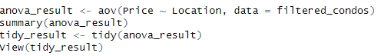

Figure 78: R Script finding ANOVA result.

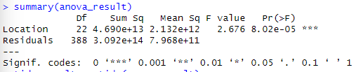

Figure 79: Summary of ANOVA result.

**aov() (Extra Features)**

The function **aov()** is used to perform ANOVA test (STHDA, n.d.).The ANOVA result shows that the Location variable has a statistically significant effect on the Price of condominiums with the common average size, F(22, 388) = 2.676, p < 0.05. The p-value of 8.02e-05 is less than the typical alpha level of 0.05 indicating that the result is against the null hypothesis. Hence, the null hypothesis is rejected as there are significant differences in mean property prices among the different locations in Kuala Lumpur which concludes that the location highly impacts the price of the Condominium with similar average size.

### **3.4.4 Findings summary**

In conclusion, a strong correlation between property size and property price is proved indicating larger properties tend to have higher prices. However, the property type usually impacts the property size and property price as different property types have different size ranges. In the analysis, condominium is concluded as the most common property type across Kuala Lumpur. However, condominium in Kuala Lumpur with similar average sizes do not have similar prices which proves that the location significantly affects the property prices.

# 4.0 Conclusion

## 4.1 Overall Discussion

We have proven the hypothesis to be true and that variables like number of rooms and car parks, location, and size indeed has a significant influence over the price of a property. For number of rooms, car parks, they will increase with the price of a property up until they go pass the normal range those 2 characteristics. Property price is also proven to have a similar relationship of growing proportionately with its size, but is limited to the size of property types, which in turn places it as having less effect on price than location. As for location, the ones with better infrastructure or can be considered hotspots belong with properties with a higher price range and properties between adjacent locations tend to have similar price ranges as well.

## 4.2 Recommendation

According to the team's in-depth analysis of the Kuala Lumpur property dataset, investors are advised to invest wisely in Kuala Lumpur's house marketing by considering different factors like property type, location, amenities, and transportation access. In our analysis, the larger the property, the higher the property price where the relationship can vary based on different property types and locations. Hotspot areas like Damansara and Bangsar offer attractive features to drive up property prices. Although the number of carparks and rooms weakly influences prices, they should be also assessed alongside other factors. In KL properties, usually 2 to 3 carparks will be provided. By taking a comprehensive view and considering the holistic context of each property, investors can purchase the most suitable property according to our analysis to maximize returns in the dynamic Kuala Lumpur market.

## 4.3 Limitation and Future Direction

One notable limitation in this analysis is the quality of dataset. The data contains a lot of irrelevant data such as “Kuala Lumpur sq. ft.” and missing data. Data replacement needs to be conducted to clean those data. However, such modifications may compromise the accuracy of the dataset comparing to the original dataset. Therefore, it would be better if clean dataset is provided for the analysis. Moreover, the time frame for the property price collected is not provided. The data might be outdated, resulting in unreliable property trends analysis.

Future studies will be concentrating on more advanced analytics techniques such as implementing machine learning to discover more complex relationships within the data and to predict the property price in specific locations using historical data.

# 5.0 Appendix

## Workload Matrix

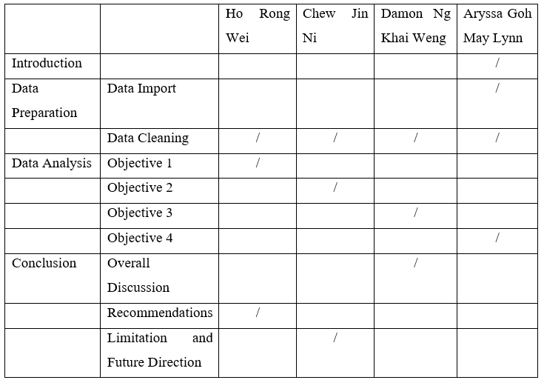

# 6.0 References

Bivand, R. (n.d.). *Moran's I test for spatial autocorrelation.* Retrieved from /r-spatial.github.io: https://r-spatial.github.io/spdep/reference/moran.test.html

Codecademy. (n.d.). *Learn Linear Regression with R*. Retrieved from https://www.codecademy.com/learn/learn-linear-regression-in-r/modules/linear-regression-in-r/cheatsheet

ggplot2. (n.d.). *Position scales for continuous data (x & y)*. Retrieved from https://ggplot2.tidyverse.org/reference/scale_continuous.html

ggplot2. (n.d.). *Save a ggplot (or other grid object) with sensible defaults - ggsave*. Retrieved from https://ggplot2.tidyverse.org/reference/ggsave.html

Postcode.my. (2024). *Malaysia Postcode Search.* Retrieved from postcode.my: https://postcode.my/location/wilayah-persekutuan/

Prabhakaran, S. (2017). *Top 50 ggplot2 Visualizations - The Master List (With Full R Code)*. Retrieved from r-statistics: http://r-statistics.co/Top50-Ggplot2-Visualizations-MasterList-R-Code.html#Marginal%20Histogram%20/%20Boxplot

PropertyGuru. (29 March, 2022). *Top 10 Most Expensive Residential and Commercial Properties In Malaysia*. Retrieved from https://www.propertyguru.com.my/property-guides/10-most-expensive-residential-and-commercial-properties-29517

R CODER. (2024). *Donut Chart in ggplot2*. Retrieved from r-charts: https://r-charts.com/part-whole/donut-chart-ggplot2/

R CODER. (2024). *Interactive maps with leaflet in R.* Retrieved from r-charts.com: https://r-charts.com/spatial/interactive-maps-leaflet/

STHDA. (n.d.). *Correlation Test Between Two Variables in R*. Retrieved from http://www.sthda.com/english/wiki/correlation-test-between-two-variables-in-r

STHDA. (n.d.). *One-Way ANOVA Test in R*. Retrieved from http://www.sthda.com/english/wiki/one-way-anova-test-in-r